UNITED STATES
SECURITIES AND EXCHANGE COMMISSION
WASHINGTON, D.C. 20549

FORM 8-K

CURRENT REPORT

Pursuant to Section 13 or 15(d) of the Securities Exchange Act of 1934

Date of Report (Date of earliest event reported): August 11, 2026

Chicago Atlantic Real Estate Finance, Inc.
(Exact name of Registrant as Specified in Its Charter)

Maryland |  | 001-41123 |  | 86-3125132
(State or Other Jurisdiction  of Incorporation) |  | (Commission File Number) |  | (IRS Employer  Identification No.)
1680 Michigan Avenue Suite 700 Miami Beach, Florida |  |  |  | 33139
(Address of Principal Executive Offices) |  |  |  | (Zip Code)

Registrant’s Telephone Number, Including Area Code: (312) 625-9295

(Former Name or Former Address, if Changed Since Last Report)

Check the appropriate box below if the Form 8-K filing is intended to simultaneously satisfy the filing obligation of the registrant under any of the following provisions:

 | ☒ | Written communications pursuant to Rule 425 under the Securities Act (17 CFR 230.425)

 | ☒ | Soliciting material pursuant to Rule 14a-12 under the Exchange Act (17 CFR 240.14a-12)

 | ☐ | Pre-commencement communications pursuant to Rule 14d-2(b) under the Exchange Act (17 CFR 240.14d-2(b))

 | ☐ | Pre-commencement communications pursuant to Rule 13e-4(c) under the Exchange Act (17 CFR 240.13e-4(c))

Securities registered pursuant to Section 12(b) of the Act:

Title of each class |  | Trading Symbol(s) |  | Name of each exchange on which registered
Common Stock, par value $0.01 per share |  | REFI |  | Nasdaq Global Market

Indicate by check mark whether the registrant is an emerging growth company as defined in Rule 405 of the Securities Act of 1933 (§ 230.405 of this chapter) or Rule 12b-2 of the Securities Exchange Act of 1934 (§ 240.12b-2 of this chapter).

Emerging growth company ☒

If an emerging growth company, indicate by check mark if the registrant has elected not to use the extended transition period for complying with any new or revised financial accounting standards provided pursuant to Section 13(a) of the Exchange Act. ☐

Item 2.02 Results of Operations and Financial Condition.

On August 11, 2026, Chicago Atlantic Real Estate Finance, Inc. (the “Company”) issued a press release announcing its financial results for the second quarter ended June 30, 2026. The text of the press release is included as Exhibit 99.1 to this Form 8-K and is incorporated herein by reference.

The information set forth under this Item 2.02, including Exhibit 99.1, is being furnished and shall not be deemed “filed” for purposes of Section 18 of the Securities Exchange Act of 1934, as amended, or otherwise subject to the liabilities of that section. The information set forth under this Item 2.02, including Exhibit 99.1, shall not be incorporated by reference into any registration statement or other document pursuant to the Securities Act of 1933, as amended, unless it is specifically incorporated by reference therein.

Item 7.01 Regulation FD Disclosure.

On August 11, 2026, the Company disseminated a presentation to be used in connection with its conference call to discuss its financial results for the second quarter ended June 30, 2026, which will be held on Tuesday, August 11, 2026, at 9:00 a.m. (eastern time). A copy of the presentation has been posted to the Company’s Investor Relations page of its website and is included herewith as Exhibit 99.2, and by this reference incorporated herein.

The information disclosed under this Item 7.01, including Exhibit 99.2 hereto, is being furnished and shall not be deemed “filed” for purposes of Section 18 of the Securities Exchange Act of 1934, as amended, or otherwise subject to the liabilities of that section. The information provided herein shall not be deemed incorporated by reference into any filing made under the Securities Act of 1933, as amended, except as expressly set forth by specific reference in such filing.

No Offer or Solicitation

This communication is not intended to and shall not constitute an offer to sell or the solicitation of an offer to sell or the solicitation of an offer to buy any securities, or a solicitation of any vote or approval, nor shall there be any sale of securities in any jurisdiction in which such offer, solicitation or sale would be unlawful prior to registration or qualification under the securities laws of any such jurisdiction. No offer of securities shall be made except by means of a prospectus meeting the requirements of Section 10 of the Securities Act of 1933, as amended (the “Securities Act”), or in a transaction exempt from the registration requirements of the Securities Act.

1

Additional Information and Where to Find It

This communication includes information relating to the proposed merger (the “Merger”) of the Company with and into Chicago Atlantic BDC, Inc. (“LIEN”), along with related proposals for which stockholder approval will be sought, pursuant to the Agreement and Plan of Merger, dated as of June 17, 2026 (the “Merger Agreement”) by and between LIEN and the Company. The Merger Agreement was unanimously approved by the Boards of Directors of both LIEN and the Company, each acting on the unanimous recommendation of its special committee of independent directors. In connection with the proposals, LIEN filed with the SEC a registration statement on Form N-14 on July 31, 2026, which includes a joint proxy statement of LIEN and the Company and a prospectus of LIEN (the “Proxy Statement/Prospectus”). This communication does not constitute an offer to sell or the solicitation of an offer to buy any securities or a solicitation of any vote or approval. No offer of securities shall be made except by means of a prospectus meeting the requirements of Section 10 of the Securities Act. STOCKHOLDERS OF LIEN AND THE COMPANY ARE URGED TO READ THE PROXY STATEMENT/PROSPECTUS, AND OTHER DOCUMENTS THAT ARE FILED OR WILL BE FILED WITH THE SEC, AS WELL AS ANY AMENDMENTS OR SUPPLEMENTS TO THESE DOCUMENTS, CAREFULLY AND IN THEIR ENTIRETY WHEN THEY BECOME AVAILABLE BECAUSE THEY WILL CONTAIN IMPORTANT INFORMATION ABOUT LIEN, THE COMPANY, THE MERGER AND THE PROPOSALS. Investors and security holders will be able to obtain the documents filed with the SEC free of charge at the SEC’s website, www.sec.gov, or from each company’s investor relations website at www.investors.chicagoatlanticbdc.com (LIEN) and www.investors.refi.reit (the Company), or by directing a request to LIEN@chicagoatlantic.com (LIEN) or IR@REFI.reit (the Company).

Participants in the Solicitation

LIEN, the Company and their respective directors and executive officers, Chicago Atlantic BDC Adviser, LLC, the external investment adviser to LIEN (the “LIEN Adviser”), and Chicago Atlantic REIT Manager, LLC, the external manager of the Company (the “Company Manager”), and their respective directors, officers, members, managers, partners, employees and affiliates, and other persons may be deemed to be participants in the solicitation of proxies from the stockholders of LIEN and the Company in connection with the Merger and the related proposals. Information regarding the persons who may, under the rules of the SEC, be deemed participants in the solicitation of the stockholders of LIEN and the Company in connection with the Merger and the related proposals, including a description of their direct or indirect interests, by security holdings or otherwise, will be included in the Proxy Statement/Prospectus and other relevant materials to be filed with the SEC when they become available. Additional information regarding the ownership of LIEN and the Company securities by their respective directors and executive officers is included in their SEC filings on Forms 3, 4 and 5, which can be found through the SEC’s website at www.sec.gov. Information about the directors and executive officers of LIEN set forth in LIEN’s proxy statement for its 2026 annual meeting of stockholders, filed with the SEC on April 30, 2026, and in LIEN’s Annual Report on Form 10-K for the fiscal year ended December 31, 2025, filed with the SEC on March 19, 2026. Information about the directors and executive officers of the Company set forth in the Company’s proxy statement for its 2026 annual meeting of stockholders, filed with the SEC on April 23, 2026, and in the Company’s Annual Report on Form 10-K for the fiscal year ended December 31, 2025, filed with the SEC on March 12, 2026. Each of these documents is available free of charge at the SEC’s website, www.sec.gov, or from LIEN’s or the Company’s investor relations website, as applicable.

2

Item 9.01 Financial Statements and Exhibits.

d) Exhibits

Exhibit  Number |  | Description
99.1 |  | Press release dated August 11, 2026.
99.2 |  | Second Quarter 2026 Earnings Supplemental Presentation dated August 11, 2026.
104 |  | Cover Page Interactive Data File (embedded within the Inline XBRL document)

3

SIGNATURES

Pursuant to the requirements of the Securities Exchange Act of 1934, the registrant has duly caused this report to be signed on its behalf by the undersigned hereunto duly authorized.

 | CHICAGO ATLANTIC REAL ESTATE FINANCE, INC.
Date: August 11, 2026 | By: | /s/ Peter Sack
 |  | Peter Sack, Co-Chief Executive Officer

4

Exhibit 99.1



Chicago Atlantic Real Estate Finance Announces Second Quarter 2026 Financial Results

CHICAGO— (August 11, 2026) Chicago Atlantic Real Estate Finance, Inc. (NASDAQ: REFI, “Chicago Atlantic”, “REFI” or the “Company”), a commercial mortgage real estate investment trust, today announced its financial results for the second quarter ended June 30, 2026.

Peter Sack, Co-Chief Executive Officer, noted, “Chicago Atlantic operates in a niche market the broader lending industry generally doesn’t serve. This often gives us the leverage to set our own terms, protect our downside, and generate yields that are increasingly hard to find anywhere else in the private credit sector. We are proud to announce $59.2 million of gross originations this quarter. However; earnings were negatively impacted by the timing of deployment as repayments occurred early in the period and deployments later in the period. Our portfolio continues to perform, and our outlook remains positive. We continue to make the strategic moves that we believe position the Company favorably as the cannabis ecosystem evolves, which includes our work toward completion of our previously announced merger with Chicago Atlantic BDC, Inc.”

Quarterly Results of Operations

 |  | For the three months ended
 |  | June 30, 2026 |  |  |  |  |  |  |  | March 31, 2026 |  |  |  |  |  |  |  | June 30, 2025
 |  | Total Amount |  |  |  | Per Share |  |  |  | Total Amount |  |  |  | Per Share |  |  |  | Total Amount |  |  |  | Per Share
OPERATING RESULTS
Net interest income |  | $ | 12,834,645 |  |  | $ | 0.59 |  |  | $ | 13,124,086 |  |  | $ | 0.61 |  |  | $ | 14,424,987 |  |  | $ | 0.67
Total expenses before provision for expected credit losses |  | $ | 4,586,025 |  |  | $ | 0.21 |  |  | $ | 4,239,871 |  |  | $ | 0.20 |  |  | $ | 4,565,322 |  |  | $ | 0.21
Net income |  | $ | 7,473,326 |  |  | $ | 0.34 |  |  | $ | 4,840,364 |  |  | $ | 0.23 |  |  | $ | 8,877,375 |  |  | $ | 0.41
(Benefit) provision for current expected credit losses |  | $ | 551,294 |  |  | $ | 0.03 |  |  | $ | 3,837,851 |  |  | $ | 0.18 |  |  | $ | 1,147,290 |  |  | $ | 0.05
Distributable earnings - basic |  | $ | 9,290,163 |  |  | $ | 0.44 |  |  | $ | 9,833,020 |  |  | $ | 0.47 |  |  | $ | 10,850,941 |  |  | $ | 0.52
Distributable earnings - diluted |  | $ | 9,290,163 |  |  | $ | 0.43 |  |  | $ | 9,833,020 |  |  | $ | 0.46 |  |  | $ | 10,850,941 |  |  | $ | 0.51
Diluted weighted average shares of common stock outstanding |  |  | 21,713,882 |  |  |  | - |  |  |  | 21,484,118 |  |  |  | - |  |  |  | 21,487,106 |  |  |  | -
Regular dividends declared |  | $ | 10,017,764 |  |  | $ | 0.47 |  |  | $ | 9,907,728 |  |  | $ | 0.47 |  |  |  | 9,905,074 |  |  | $ | 0.47
PORTFOLIO PERFORMANCE
Total loan principal outstanding |  | $ | 453,125,652 |  |  |  |  |  |  | $ | 413,589,833 |  |  |  |  |  |  | $ | 421,918,148
Portfolio companies |  |  | 26 |  |  |  |  |  |  |  | 25 |  |  |  |  |  |  |  | 30
Unfunded commitments |  | $ | 2,355,293 |  |  |  |  |  |  | $ | 4,450,293 |  |  |  |  |  |  | $ | 16,595,000
Gross unlevered weighted average yield to maturity |  |  | 15.8 | % |  |  |  |  |  |  | 15.8 | % |  |  |  |  |  |  | 16.8 | %
Aggregate loan portfolio bearing a variable interest rate |  |  | 62.5 | % |  |  |  |  |  |  | 64.8 | % |  |  |  |  |  |  | 59.3 | %
Book value per share |  | $ | 14.15 |  |  |  |  |  |  | $ | 14.39 |  |  |  |  |  |  | $ | 14.71
Debt/equity ratio |  |  | 46.6 | % |  |  |  |  |  |  | 38.4 | % |  |  |  |  |  |  | 38.8 | %

Portfolio Activity

The following table summarizes the Company’s primary investment portfolio activities:

 |  | Three months  ended  March 31,  2026 |  |  |  | Three months  ended  June 30,  2026 |  |  |  | Six months  ended  June 30,  2026 |  |  |  | Portfolio
 |  | Principal |  |  |  | Principal |  |  |  | Principal |  |  |  | Companies
Loan principal, beginning of period |  | $ | 411,075,088 |  |  | $ | 413,589,833 |  |  | $ | 411,075,088 |  |  |  | 26
Principal Advances1
New portfolio companies |  |  | 16,211,500 |  |  |  | 56,225,081 |  |  |  | 72,436,581 |  |  |  | 4
Existing portfolio companies |  |  | 37,868,649 |  |  |  | 2,978,549 |  |  |  | 40,847,198 |  |  |  | 4
 |  |  | 54,080,149 |  |  |  | 59,203,630 |  |  |  | 113,283,779
Scheduled Principal Repayments
New portfolio companies |  |  | - |  |  |  | - |  |  |  | -
Existing portfolio companies |  |  | (3,349,541 | ) |  |  | (3,341,880 | ) |  |  | (6,691,421 | ) |  |  | 13
 |  |  | (3,349,541 | ) |  |  | (3,341,880 | ) |  |  | (6,691,421 | )
Unscheduled Principal Repayments
New portfolio companies |  |  | - |  |  |  | - |  |  |  | -
Existing portfolio companies |  |  | (48,215,862 | ) |  |  | (16,325,932 | ) |  |  | (64,541,794 | ) |  |  | 9
 |  |  | (48,215,862 | ) |  |  | (16,325,932 | ) |  |  | (64,541,794 | )
Net change in principal outstanding |  |  | 2,514,745 |  |  |  | 39,535,819 |  |  |  | 42,050,564
Loan principal, end of period |  | $ | 413,589,833 |  |  | $ | 453,125,652 |  |  | $ | 453,125,652 |  |  |  | 26

 | 1 | Principal advances include capitalized paid-in-kind (“PIK”) interest and/or other fees, if any, that were capitalized to the outstanding loan balance of the subject loan(s).

Recent Developments

 | ● | Koach Transaction. On July 9, 2026, the Company entered into a Loan Agreement with Koach Capital Fund I LLC, Koach Capital Fund II LP, Koach Capital Fund III LP and their respective wholly owned subsidiaries (collectively, “Koach”), pursuant to which the Company issued 4,306,754 shares of Common Stock at a price of $14.53 per share, in a private placement transaction, in exchange for second lien promissory notes issued by Koach in an aggregate principal amount of approximately $62.5 million (the “Koach Notes”). The shares issued represent approximately 16.8% of the Common Stock outstanding immediately after giving effect to the issuance. The Koach Notes are individually secured by mortgages on 32 retail and related properties leased to cannabis operators, are subordinate to senior first lien indebtedness of approximately $39 million as of the closing date, bear interest at an aggregate rate of 12.0% per annum (10.0% cash and 2.0% payable in kind), provide for an exit fee of 2.5x the commitment amount of each Note, and have an aggregate weighted average time to maturity of approximately 12.0 years. Additional information regarding the transaction is contained in the Company’s Current Report on Form 8-K filed with the SEC on July 13, 2026.

 | ● | Pending Merger with Chicago Atlantic BDC, Inc. On June 17, 2026, the Company entered into an Agreement and Plan of Merger with Chicago Atlantic BDC, Inc. (NASDAQ: LIEN); “LIEN”), an affiliated business development company that is externally managed by an affiliate of the Company’s manager, pursuant to which the Company will merge with and into LIEN, with LIEN continuing as the surviving company (the “Merger”). At closing, REFI stockholders will receive a number of shares of LIEN common stock determined based on the ratio of REFI’s net asset value (“NAV”) per share, as adjusted in accordance with the Merger Agreement, to LIEN’s NAV per share, similarly adjusted, in each case as determined shortly prior to closing. Based on the respective NAVs of REFI and LIEN as of March 31, 2026, and without giving effect to the Koach transaction described above or any other changes in the inputs to the exchange ratio occurring after March 31, 2026, former REFI stockholders would be expected to own approximately 50.5% of LIEN immediately following the Merger. The shares of Common Stock issued in the Koach transaction will be reflected in the inputs used to determine the exchange ratio at closing, and the actual pro forma ownership percentage will depend on the NAV ratio calculated shortly prior to closing and may differ from the March 31, 2026 estimate. Completion of the Merger is subject to the approval of stockholders of both REFI and LIEN, including approval by REFI stockholders of REFI’s election to be regulated as a business development company under the Investment Company Act of 1940 and approval of a new investment advisory agreement, as well as regulatory approvals, third-party consents and other customary closing conditions. Assuming these conditions are satisfied, the Merger is expected to close in the fourth quarter of 2026. There can be no assurance that the Merger will be completed on the anticipated terms or timing, or at all. Additional information regarding the Merger is set forth below under “Additional Information and Where to Find It.”

2

Capital Activity

 | ● | As of June 30, 2026, the Company had approximately $141.1 million of total drawn leverage, comprised of $91.1 million drawn on the secured revolving credit facility and $50.0 million of outstanding senior unsecured notes due 2028.

 | ● | On July 9, 2026, the Company issued 4,306,754 shares of Common Stock to Koach in a private placement transaction in exchange for approximately $62.5 million of second lien promissory notes. See “Recent Developments — Koach Transaction” above.

 | ● | As of August 11, 2026, the Company has $15.7 million available on its secured revolving credit facility, and total liquidity, net of estimated liabilities, of approximately $16.0 million.
﻿
2026 Outlook

Chicago Atlantic offered the following outlook for full year 2026:

 | ● | The Company expects to maintain a dividend payout ratio based on Distributable Earnings per weighted average diluted share of approximately 90% to 100% on a full year basis.

 | ● | If the Company’s taxable income requires additional distribution in excess of the regular quarterly dividend, in order to meet its 2026 taxable income distribution requirements, the Company expects to meet that requirement with a special dividend in the fourth quarter of 2026.

The foregoing outlook assumes that the Company continues to operate on a standalone basis and does not reflect the effects of the pending Merger, including any restrictions on dividends or other actions during the pendency of the Merger under the terms of the Merger Agreement. The declaration of any dividend, including any special dividend, remains subject to authorization by the Board and to the terms of the Merger Agreement.

Conference Call and Quarterly Earnings Supplemental Details

Chicago Atlantic will host a conference call and live audio webcast, both open for the general public to hear, later today at 9:00 a.m. Eastern Time. The number to call for this interactive teleconference is (833) 630-1956 (international callers: 412-317-1837). The live audio webcast of the Company’s quarterly conference call will be available online in the Investor Relations section of the Company’s website at www.refi.reit. The online replay will be available approximately one hour after the end of the call and archived for one year.

Chicago Atlantic posted its Second Quarter 2026 Earnings Supplemental on the Investor Relations page of its website. Chicago Atlantic routinely posts important information for investors on its website, www.refi.reit. The Company intends to use this website as a means of disclosing material information, for complying with our disclosure obligations under Regulation FD and to post and update investor presentations and similar materials on a regular basis. The Company encourages investors, analysts, the media and others interested in Chicago Atlantic to monitor the Investor Relations page of its website, in addition to following its press releases, SEC filings, publicly available earnings calls, presentations, webcasts and other information posted from time to time on the website. Please visit the IR Resources section of the website to sign up for email notifications.

About Chicago Atlantic Real Estate Finance, Inc.

Chicago Atlantic Real Estate Finance, Inc. (NASDAQ: REFI) is a market-leading commercial mortgage REIT utilizing significant real estate, credit and cannabis expertise to originate senior secured loans primarily to state-licensed cannabis operators in limited-license states in the United States. REFI is part of the Chicago Atlantic platform, which has offices in Chicago, Miami, New York, and London.

3

Forward-Looking Statements

This release contains forward-looking statements within the meaning of the Private Securities Litigation Reform Act of 1995 that reflect the Company’s current views and projections with respect to, among other things, future events and financial performance, including statements regarding the proposed Merger with LIEN and its expected timing and effects, the expected pro forma ownership of former REFI stockholders in LIEN following the Merger, the Company’s July 2026 acquisition of second lien notes from Koach and the performance of such notes and their underlying collateral, the expected implementation and effects of federal rescheduling of medical cannabis, the Company’s dividend expectations, and the Company’s future operations and strategies. Words such as “believes,” “expects,” “will,” “intends,” “plans,” “guidance,” “estimates,” “projects,” “anticipates,” “future” and similar expressions are intended to identify forward-looking statements. These statements are not guarantees of future performance and are subject to numerous risks and uncertainties, including, without limitation: (i) the risk that the proposed Merger may not be completed on the anticipated terms or timing, or at all; (ii) the failure to obtain the required stockholder approvals of REFI or LIEN, including approval of REFI’s election to be regulated as a business development company and approval of a new investment advisory agreement; (iii) the failure to satisfy other conditions to closing, including regulatory approvals and third-party consents; (iv) the effect of the announcement or pendency of the Merger on the Company’s business, operating results, and relationships with borrowers, employees and other counterparties; (v) risks that the Merger may divert management’s attention from the Company’s ongoing business; (vi) the outcome of any legal proceedings that may be instituted against REFI or LIEN related to the Merger; (vii) the amount of costs, fees and expenses related to the Merger; (viii) developments in the cannabis industry, including federal, state and local legal and regulatory changes and the implementation of federal rescheduling; (ix) changes in interest rates, credit spreads and macroeconomic conditions; (x) risks related to the Koach transaction, including credit and collateral risks associated with the Koach Notes, the subordination of the Koach Notes to senior first lien indebtedness, and the impact of the associated share issuance on the exchange ratio for the Merger; and (xi) the other risks identified in the Company’s filings with the SEC, including its Annual Report on Form 10-K for the year ended December 31, 2025 and subsequent Quarterly Reports on Form 10-Q, and in the registration statement on Form N-14 filed by LIEN with the SEC on July 31, 2026, including the joint proxy statement/prospectus contained therein. New risks and uncertainties arise over time, and it is not possible to predict those events or how they may affect us. We do not undertake any obligation to publicly update or revise any forward-looking statements, whether as a result of new information, future events or otherwise, except as required by law.

No Offer or Solicitation

This press release is not intended to and shall not constitute an offer to sell or the solicitation of an offer to sell or the solicitation of an offer to buy any securities, or a solicitation of any vote or approval, nor shall there be any sale of securities in any jurisdiction in which such offer, solicitation or sale would be unlawful prior to registration or qualification under the securities laws of any such jurisdiction. No offer of securities shall be made except by means of a prospectus meeting the requirements of Section 10 of the Securities Act of 1933, as amended (the “Securities Act”), or in a transaction exempt from the registration requirements of the Securities Act.

Additional Information and Where to Find It

This communication includes information relating to the proposed merger (the “Merger”) of REFI with and into Chicago Atlantic BDC, Inc. (“LIEN”), along with related proposals for which stockholder approval will be sought, pursuant to the Agreement and Plan of Merger, dated as of June 17, 2026 (the “Merger Agreement”) by and between LIEN and REFI. The Merger Agreement was unanimously approved by the Boards of Directors of both LIEN and REFI, each acting on the unanimous recommendation of its special committee of independent directors (each, a “Special Committee”). In connection with the proposals, LIEN intends to file relevant materials with the SEC, including a registration statement on Form N-14 (filed July 31, 2026), which includes a joint proxy statement of LIEN and REFI and a prospectus of LIEN (the “Proxy Statement/Prospectus”). This communication does not constitute an offer to sell or the solicitation of an offer to buy any securities or a solicitation of any vote or approval. No offer of securities shall be made except by means of a prospectus meeting the requirements of Section 10 of the Securities Act. STOCKHOLDERS OF LIEN AND REFI ARE URGED TO READ THE PROXY STATEMENT/PROSPECTUS, AND OTHER DOCUMENTS THAT ARE FILED OR WILL BE FILED WITH THE SEC, AS WELL AS ANY AMENDMENTS OR SUPPLEMENTS TO THESE DOCUMENTS, CAREFULLY AND IN THEIR ENTIRETY WHEN THEY BECOME AVAILABLE BECAUSE THEY WILL CONTAIN IMPORTANT INFORMATION ABOUT LIEN, REFI, THE MERGER AND THE PROPOSALS. Investors and security holders will be able to obtain the documents filed with the SEC free of charge at the SEC’s website, www.sec.gov, or from each company’s investor relations website at www.investors.chicagoatlanticbdc.com (LIEN) and www.investors.refi.reit (REFI), or by directing a request to LIEN@chicagoatlantic.com (LIEN) or IR@REFI.reit (REFI).

4

Participants in the Solicitation

LIEN, REFI and their respective directors and executive officers, Chicago Atlantic BDC Adviser, LLC, the external investment adviser to LIEN (the “LIEN Adviser”), and Chicago Atlantic REIT Manager, LLC, the external manager of REFI (the “Company Manager”), and their respective directors, officers, members, managers, partners, employees and affiliates, and other persons may be deemed to be participants in the solicitation of proxies from the stockholders of LIEN and REFI in connection with the Merger and the related proposals. Information regarding the persons who may, under the rules of the SEC, be deemed participants in the solicitation of the stockholders of LIEN and REFI in connection with the Merger and the related proposals, including a description of their direct or indirect interests, by security holdings or otherwise, will be included in the Proxy Statement/Prospectus and other relevant materials to be filed with the SEC when they become available. Additional information regarding the ownership of LIEN and REFI securities by their respective directors and executive officers is included in their SEC filings on Forms 3, 4 and 5, which can be found through the SEC’s website at www.sec.gov. Information about the directors and executive officers of LIEN set forth in LIEN’s proxy statement for its 2026 annual meeting of stockholders, filed with the SEC on April 30, 2026, and in LIEN’s Annual Report on Form 10-K for the fiscal year ended December 31, 2025, filed with the SEC on March 19, 2026. Information about the directors and executive officers of REFI set forth in REFI’s proxy statement for its 2026 annual meeting of stockholders, filed with the SEC on April 23, 2026, and in REFI’s Annual Report on Form 10-K for the fiscal year ended December 31, 2025, filed with the SEC on March 12, 2026. Each of these documents is available free of charge at the SEC’s website, www.sec.gov, or from LIEN’s or REFI’s investor relations website, as applicable.

Contact:

Tripp Sullivan, Lisa Kampf
SCR Partners
IR@REFI.reit

5

CHICAGO ATLANTIC REAL ESTATE FINANCE, INC.
CONSOLIDATED BALANCE SHEETS

 |  | June 30,  2026 |  |  |  | December 31, 2025
 |  | (unaudited)
Assets
Loans held for investment |  | $ | 304,479,345 |  |  | $ | 332,772,244
Loans held for investment - related party (Note 8) |  |  | 103,420,472 |  |  |  | 76,183,323
Loans held for investment, at carrying value |  |  | 407,899,817 |  |  |  | 408,955,567
Current expected credit loss reserve |  |  | (9,370,918 | ) |  |  | (5,062,785 | )
Loans held for investment at carrying value, net |  |  | 398,528,899 |  |  |  | 403,892,782
Loans, at fair value - related party (amortized cost of $40,612,435 and $0, respectively) (Note 8) |  |  | 40,612,435 |  |  |  | -
Cash and cash equivalents |  |  | 13,351,699 |  |  |  | 14,948,884
Interest receivable |  |  | 5,077,545 |  |  |  | 4,009,800
Other receivables and assets, net |  |  | 2,946,847 |  |  |  | 874,245
Related party receivables |  |  | 1,181,661 |  |  |  | 1,189,937
Total Assets |  | $ | 461,699,086 |  |  | $ | 424,915,648
Liabilities
Revolving loan |  | $ | 91,050,000 |  |  | $ | 49,100,000
Notes payable, net |  |  | 49,452,551 |  |  |  | 49,334,459
Dividend payable |  |  | 10,639,254 |  |  |  | 11,157,220
Related party payables |  |  | 2,061,428 |  |  |  | 2,214,920
Management and incentive fees payable |  |  | 1,604,328 |  |  |  | 3,098,576
Interest payable |  |  | 1,673,514 |  |  |  | 1,348,334
Accounts payable and other liabilities |  |  | 1,039,790 |  |  |  | 834,977
Interest reserve |  |  | 2,530,183 |  |  |  | 12,686
Total Liabilities |  |  | 160,051,048 |  |  |  | 117,101,172
Commitments and contingencies (Note 9)
Stockholders’ equity
Common stock, par value $0.01 per share, 100,000,000 shares authorized and 21,314,392 and 21,080,272 shares issued and outstanding, respectively |  |  | 213,144 |  |  |  | 210,803
Additional paid-in-capital |  |  | 324,946,445 |  |  |  | 323,125,854
Accumulated deficit |  |  | (23,511,551 | ) |  |  | (15,522,181 | )
Total stockholders’ equity |  |  | 301,648,038 |  |  |  | 307,814,476
Total liabilities and stockholders’ equity |  | $ | 461,699,086 |  |  | $ | 424,915,648

6

CHICAGO ATLANTIC REAL ESTATE FINANCE, INC.
CONSOLIDATED STATEMENTS OF INCOME
(UNAUDITED)

 |  | For the three months ended  June 30, |  |  |  |  |  |  |  | For the six months ended  June 30,
 |  | 2026 |  |  |  | 2025 |  |  |  | 2026 |  |  |  | 2025
Revenues
Interest income |  | $ | 15,219,022 |  |  | $ | 16,502,035 |  |  | $ | 30,383,710 |  |  | $ | 31,609,350
Interest expense |  |  | (2,384,377 | ) |  |  | (2,077,048 | ) |  |  | (4,424,979 | ) |  |  | (4,142,430 | )
Net interest income |  |  | 12,834,645 |  |  |  | 14,424,987 |  |  |  | 25,958,731 |  |  |  | 27,466,920
Expenses
Management and incentive fees, net |  |  | 1,604,328 |  |  |  | 1,932,957 |  |  |  | 3,323,823 |  |  |  | 3,668,490
General and administrative expense |  |  | 1,529,035 |  |  |  | 1,271,124 |  |  |  | 2,680,508 |  |  |  | 2,467,231
Professional fees |  |  | 495,084 |  |  |  | 480,113 |  |  |  | 998,633 |  |  |  | 973,059
Stock based compensation |  |  | 957,578 |  |  |  | 881,128 |  |  |  | 1,822,932 |  |  |  | 1,530,440
Provision (benefit) for current expected credit losses |  |  | 551,294 |  |  |  | 1,147,290 |  |  |  | 4,389,145 |  |  |  | 74,014
Total expenses |  |  | 5,137,319 |  |  |  | 5,712,612 |  |  |  | 13,215,041 |  |  |  | 8,713,234
Change in unrealized (loss)/gain on investment |  |  | (224,000 | ) |  |  | 165,000 |  |  |  | (430,000 | ) |  |  | 165,000
Net income before income taxes |  |  | 7,473,326 |  |  |  | 8,877,375 |  |  |  | 12,313,690 |  |  |  | 18,918,686
Income tax expense |  |  | - |  |  |  | - |  |  |  | - |  |  |  | -
Net income |  | $ | 7,473,326 |  |  | $ | 8,877,375 |  |  | $ | 12,313,690 |  |  | $ | 18,918,686
Earnings per common share:
Basic earnings per common share |  | $ | 0.35 |  |  | $ | 0.42 |  |  | $ | 0.58 |  |  | $ | 0.90
Diluted earnings per common share |  | $ | 0.34 |  |  | $ | 0.41 |  |  | $ | 0.57 |  |  | $ | 0.89
Weighted average number of common shares outstanding:
Basic weighted average shares of common stock outstanding |  |  | 21,242,557 |  |  |  | 21,002,787 |  |  |  | 21,161,863 |  |  |  | 20,931,025
Diluted weighted average shares of common stock outstanding |  |  | 21,713,882 |  |  |  | 21,487,106 |  |  |  | 21,599,634 |  |  |  | 21,376,645

7

Distributable Earnings

In addition to using certain financial metrics prepared in accordance with GAAP to evaluate our performance, we also use Distributable Earnings to evaluate our performance. Distributable Earnings is a measure that is not prepared in accordance with GAAP. We define Distributable Earnings as, for a specified period, the net income (loss) computed in accordance with GAAP, excluding (i) non-cash equity compensation expense, (ii) depreciation and amortization, (iii) any unrealized gains, losses or other non-cash items recorded in net income (loss) for the period, regardless of whether such items are included in other comprehensive income or loss, or in net income (loss); provided that Distributable Earnings does not exclude, in the case of investments with a deferred interest feature (such as OID, debt instruments with PIK interest and zero coupon securities), accrued income that we have not yet received in cash, (iv) provision for current expected credit losses and (v) one-time events pursuant to changes in GAAP and certain non-cash charges, in each case after discussions between our Manager and our independent directors and after approval by a majority of such independent directors. We believe providing Distributable Earnings on a supplemental basis to our net income as determined in accordance with GAAP is helpful to stockholders in assessing the overall performance of our business. As a REIT, we are required to distribute at least 90% of our annual REIT taxable income and to pay tax at regular corporate rates to the extent that we annually distribute less than 100% of such taxable income. Given these requirements and our belief that dividends are generally one of the principal reasons that stockholders invest in our common stock, we generally intend to attempt to pay dividends to our stockholders in an amount equal to our net taxable income, if and to the extent authorized by our Board. Distributable Earnings is one of many factors considered by our Board in authorizing dividends and, while not a direct measure of net taxable income, over time, the measure can be considered a useful indicator of our dividends.

In our Annual Report on Form 10-K for the year ended December 31, 2025, we defined Distributable Earnings so that, in addition to the exclusions noted above, the term also excluded from net income Incentive Compensation paid to our Manager. We believe that revising the term Distributable Earnings so that it is presented net of Incentive Compensation, while not a direct measure of net taxable income, over time, can be considered a more useful indicator of our ability to pay dividends. This adjustment to the calculation of Distributable Earnings has no impact on period-to-period comparisons. Distributable Earnings should not be considered as substitutes for GAAP net income. We caution readers that our methodology for calculating Distributable Earnings may differ from the methodologies employed by other REITs to calculate the same or similar supplemental performance measures, and as a result, our reported Distributable Earnings may not be comparable to similar measures presented by other REITs.

 |  | Three months ended |  |  |  |  |  |  |  | Six months ended
 |  | June 30,  2026 |  |  |  | June 30,  2025 |  |  |  | June 30,  2026 |  |  |  | June 30,  2025
Net Income |  | $ | 7,473,326 |  |  | $ | 8,877,375 |  |  | $ | 12,313,690 |  |  | $ | 18,918,686
Adjustments to net income
Stock based compensation |  |  | 957,578 |  |  |  | 881,128 |  |  |  | 1,822,932 |  |  |  | 1,530,440
Amortization of debt issuance costs |  |  | 83,965 |  |  |  | 110,148 |  |  |  | 167,415 |  |  |  | 220,458
Provision (benefit) for current expected credit losses |  |  | 551,294 |  |  |  | 1,147,290 |  |  |  | 4,389,145 |  |  |  | 74,014
Change in unrealized (loss)/gain on investment |  |  | 224,000 |  |  |  | (165,000 | ) |  |  | 430,000 |  |  |  | (165,000 | )
Distributable Earnings |  | $ | 9,290,163 |  |  | $ | 10,850,941 |  |  | $ | 19,123,182 |  |  | $ | 20,578,598
Basic weighted average shares of common stock outstanding (in shares) |  |  | 21,242,557 |  |  |  | 21,002,787 |  |  |  | 21,161,863 |  |  |  | 20,931,025
Basic Distributable Earnings per Weighted Average Share |  | $ | 0.44 |  |  | $ | 0.52 |  |  | $ | 0.90 |  |  | $ | 0.98
Diluted weighted average shares of common stock outstanding (in shares) |  |  | 21,713,882 |  |  |  | 21,487,106 |  |  |  | 21,599,634 |  |  |  | 21,376,645
Diluted Distributable Earnings per Weighted Average Share |  | $ | 0.43 |  |  | $ | 0.51 |  |  | $ | 0.89 |  |  | $ | 0.96

8

Exhibit 99.2

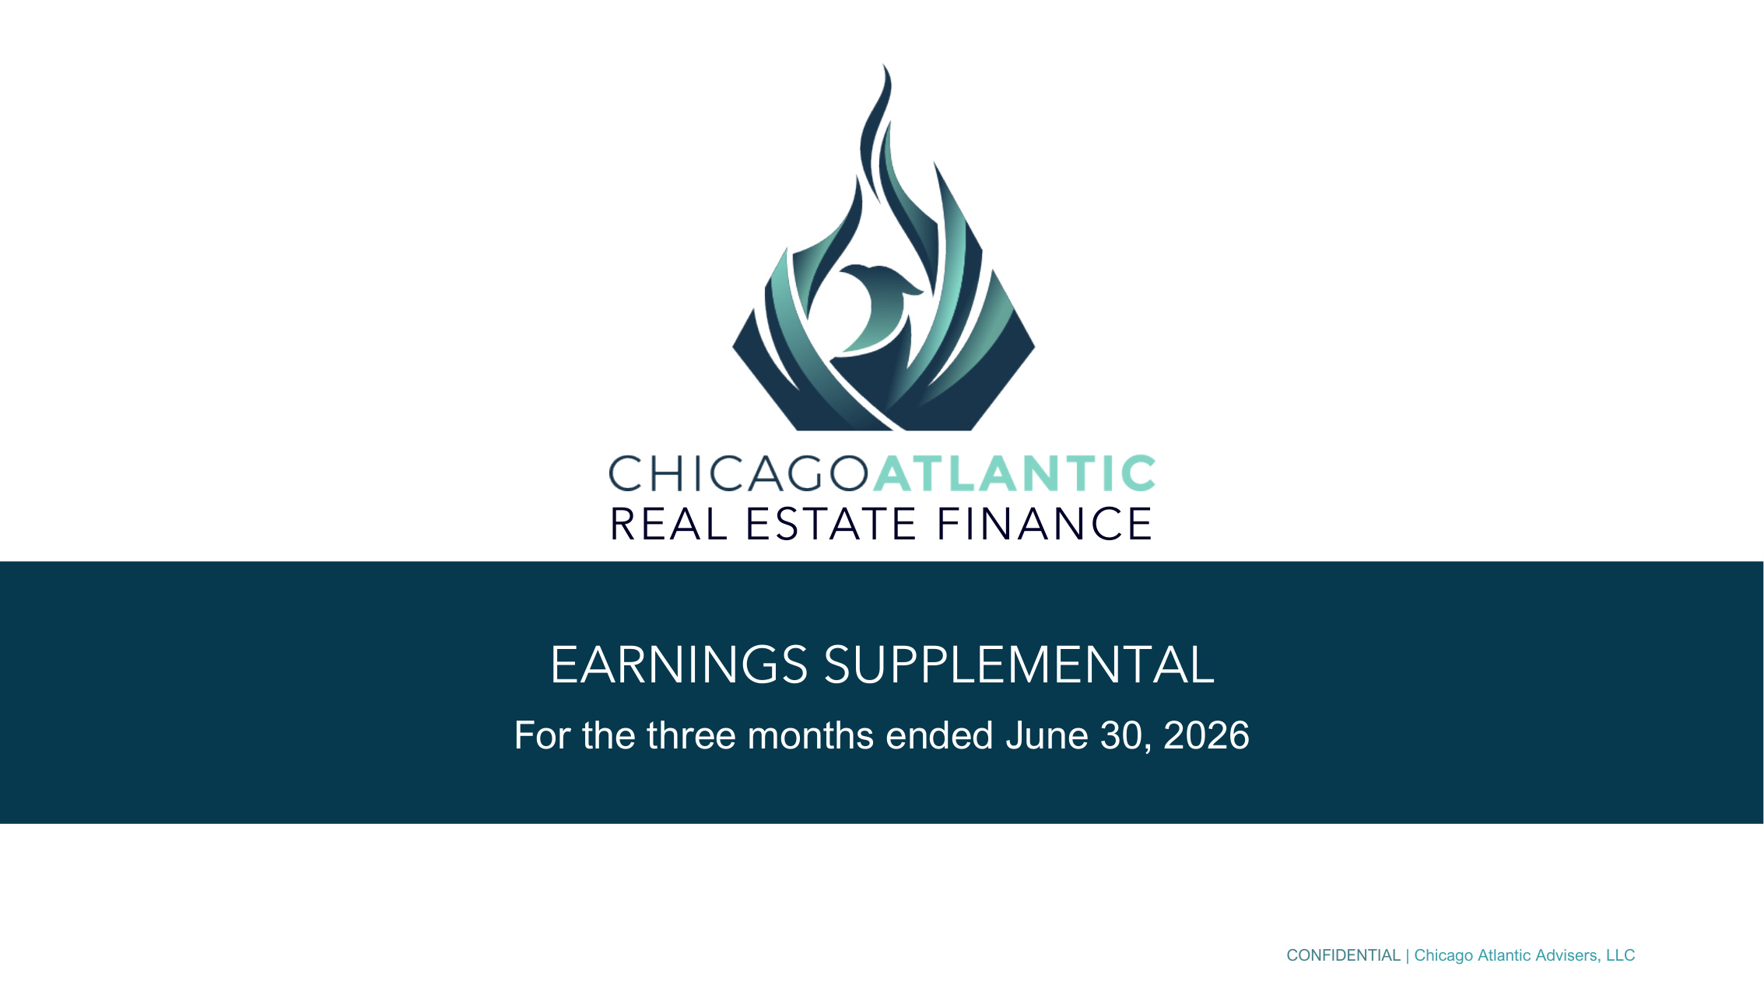
CONFIDENTIAL | Chicago Atlantic Advisers, LLC EARNINGS SUPPLEMENTAL For the three months ended June 30, 2026 REAL ESTATE FINANCE

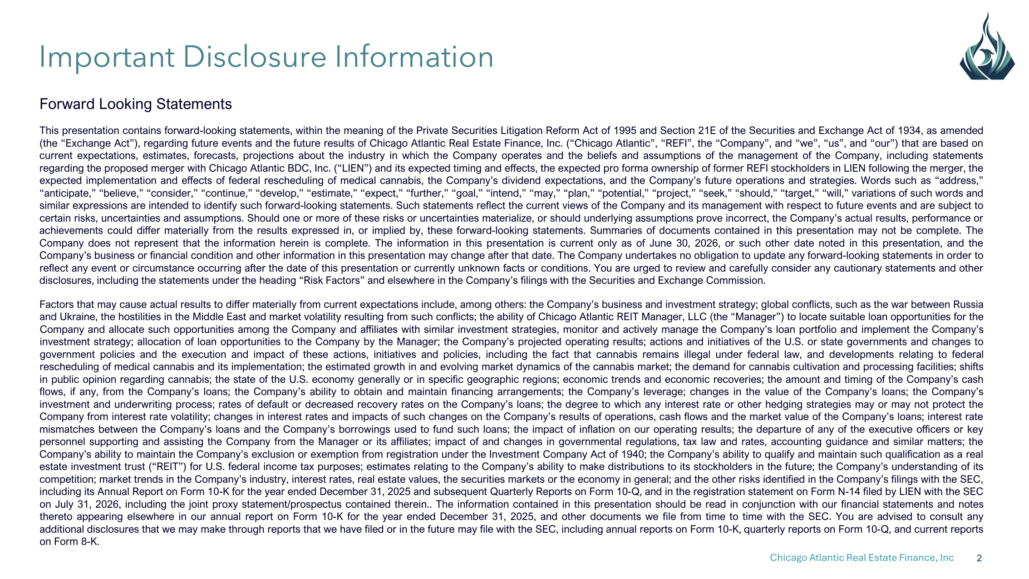
Chicago Atlantic Real Estate Finance, Inc 2 Forward Looking Statements This presentation contains forward-looking statements, within the meaning of the Private Securities Litigation Reform Act of 1995 and Section 21E of the Securities and Exchange Act of 1934, as amended (the "Exchange Act"), regarding future events and the future results of Chicago Atlantic Real Estate Finance, Inc. ("Chicago Atlantic", "REFI", the "Company", and "we", "us", and "our") that are based on current expectations, estimates, forecasts, projections about the industry in which the Company operates and the beliefs and assumptions of the management of the Company, including statements regarding the proposed merger with Chicago Atlantic BDC, Inc. ("LIEN") and its expected timing and effects, the expected pro forma ownership of former REFI stockholders in LIEN following the merger, the expected implementation and effects of federal rescheduling of medical cannabis, the Company's dividend expectations, and the Company's future operations and strategies. Words such as "address," "anticipate," "believe," "consider," "continue," "develop," "estimate," "expect," "further," "goal," "intend," "may," "plan," "potential," "project," "seek," "should," "target," "will," variations of such words and similar expressions are intended to identify such forward-looking statements. Such statements reflect the current views of the Company and its management with respect to future events and are subject to certain risks, uncertainties and assumptions. Should one or more of these risks or uncertainties materialize, or should underlying assumptions prove incorrect, the Company's actual results, performance or achievements could differ materially from the results expressed in, or implied by, these forward-looking statements. Summaries of documents contained in this presentation may not be complete. The Company does not represent that the information herein is complete. The information in this presentation is current only as of June 30, 2026, or such other date noted in this presentation, and the Company's business or financial condition and other information in this presentation may change after that date. The Company undertakes no obligation to update any forward-looking statements in order to reflect any event or circumstance occurring after the date of this presentation or currently unknown facts or conditions. You are urged to review and carefully consider any cautionary statements and other disclosures, including the statements under the heading "Risk Factors" and elsewhere in the Company's filings with the Securities and Exchange Commission. Factors that may cause actual results to differ materially from current expectations include, among others: the Company's business and investment strategy; global conflicts, such as the war between Russia and Ukraine, the hostilities in the Middle East and market volatility resulting from such conflicts; the ability of Chicago Atlantic REIT Manager, LLC (the "Manager") to locate suitable loan opportunities for the Company and allocate such opportunities among the Company and affiliates with similar investment strategies, monitor and actively manage the Company's loan portfolio and implement the Company's investment strategy; allocation of loan opportunities to the Company by the Manager; the Company's projected operating results; actions and initiatives of the U.S. or state governments and changes to government policies and the execution and impact of these actions, initiatives and policies, including the fact that cannabis remains illegal under federal law, and developments relating to federal rescheduling of medical cannabis and its implementation; the estimated growth in and evolving market dynamics of the cannabis market; the demand for cannabis cultivation and processing facilities; shifts in public opinion regarding cannabis; the state of the U.S. economy generally or in specific geographic regions; economic trends and economic recoveries; the amount and timing of the Company's cash flows, if any, from the Company's loans; the Company's ability to obtain and maintain financing arrangements; the Company's leverage; changes in the value of the Company's loans; the Company's investment and underwriting process; rates of default or decreased recovery rates on the Company's loans; the degree to which any interest rate or other hedging strategies may or may not protect the Company from interest rate volatility; changes in interest rates and impacts of such changes on the Company's results of operations, cash flows and the market value of the Company's loans; interest rate mismatches between the Company's loans and the Company's borrowings used to fund such loans; the impact of inflation on our operating results; the departure of any of the executive officers or key personnel supporting and assisting the Company from the Manager or its affiliates; impact of and changes in governmental regulations, tax law and rates, accounting guidance and similar matters; the Company's ability to maintain the Company's exclusion or exemption from registration under the Investment Company Act of 1940; the Company's ability to qualify and maintain such qualification as a real estate investment trust ("REIT") for U.S. federal income tax purposes; estimates relating to the Company's ability to make distributions to its stockholders in the future; the Company's understanding of its competition; market trends in the Company's industry, interest rates, real estate values, the securities markets or the economy in general; and the other risks identified in the Company's filings with the SEC, including its Annual Report on Form 10-K for the year ended December 31, 2025 and subsequent Quarterly Reports on Form 10-Q, and in the registration statement on Form N-14 filed by LIEN with the SEC on July 31, 2026, including the joint proxy statement/prospectus contained therein.. The information contained in this presentation should be read in conjunction with our financial statements and notes thereto appearing elsewhere in our annual report on Form 10-K for the year ended December 31, 2025, and other documents we file from time to time with the SEC. You are advised to consult any additional disclosures that we may make through reports that we have filed or in the future may file with the SEC, including annual reports on Form 10-K, quarterly reports on Form 10-Q, and current reports on Form 8-K. Important Disclosure Information

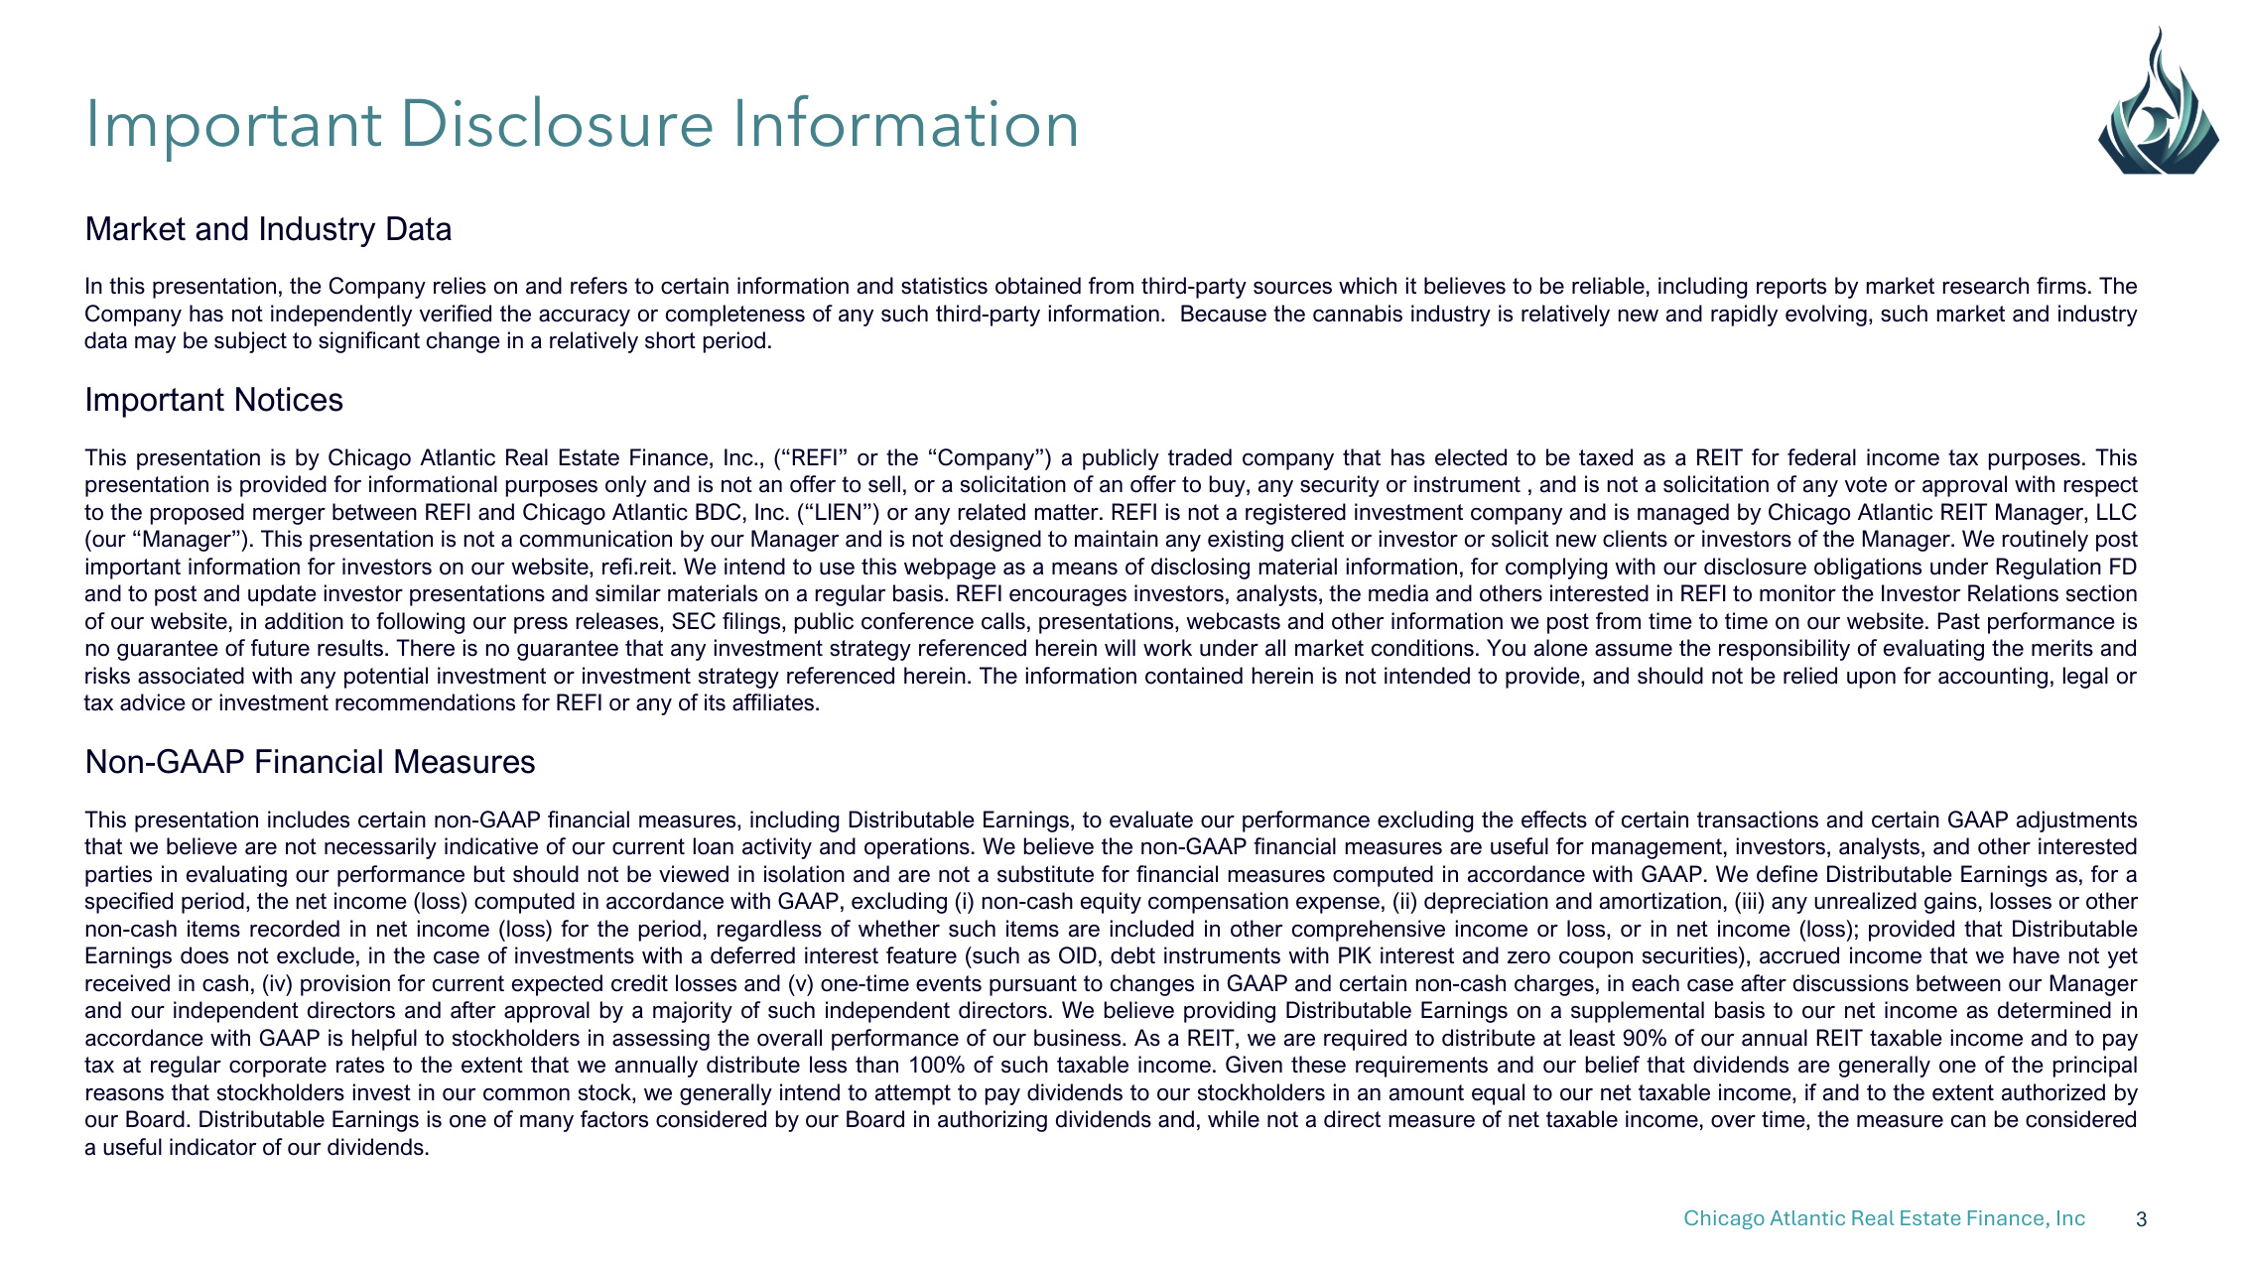
Chicago Atlantic Real Estate Finance, Inc 3 Market and Industry Data In this presentation, the Company relies on and refers to certain information and statistics obtained from third-party sources which it believes to be reliable, including reports by market research firms. The Company has not independently verified the accuracy or completeness of any such third-party information. Because the cannabis industry is relatively new and rapidly evolving, such market and industry data may be subject to significant change in a relatively short period. Important Notices This presentation is by Chicago Atlantic Real Estate Finance, Inc., ("REFI" or the "Company") a publicly traded company that has elected to be taxed as a REIT for federal income tax purposes. This presentation is provided for informational purposes only and is not an offer to sell, or a solicitation of an offer to buy, any security or instrument , and is not a solicitation of any vote or approval with respect to the proposed merger between REFI and Chicago Atlantic BDC, Inc. ("LIEN") or any related matter. REFI is not a registered investment company and is managed by Chicago Atlantic REIT Manager, LLC (our "Manager"). This presentation is not a communication by our Manager and is not designed to maintain any existing client or investor or solicit new clients or investors of the Manager. We routinely post important information for investors on our website, refi.reit. We intend to use this webpage as a means of disclosing material information, for complying with our disclosure obligations under Regulation FD and to post and update investor presentations and similar materials on a regular basis. REFI encourages investors, analysts, the media and others interested in REFI to monitor the Investor Relations section of our website, in addition to following our press releases, SEC filings, public conference calls, presentations, webcasts and other information we post from time to time on our website. Past performance is no guarantee of future results. There is no guarantee that any investment strategy referenced herein will work under all market conditions. You alone assume the responsibility of evaluating the merits and risks associated with any potential investment or investment strategy referenced herein. The information contained herein is not intended to provide, and should not be relied upon for accounting, legal or tax advice or investment recommendations for REFI or any of its affiliates. Non-GAAP Financial Measures This presentation includes certain non-GAAP financial measures, including Distributable Earnings, to evaluate our performance excluding the effects of certain transactions and certain GAAP adjustments that we believe are not necessarily indicative of our current loan activity and operations. We believe the non-GAAP financial measures are useful for management, investors, analysts, and other interested parties in evaluating our performance but should not be viewed in isolation and are not a substitute for financial measures computed in accordance with GAAP. We define Distributable Earnings as, for a specified period, the net income (loss) computed in accordance with GAAP, excluding (i) non-cash equity compensation expense, (ii) depreciation and amortization, (iii) any unrealized gains, losses or other non-cash items recorded in net income (loss) for the period, regardless of whether such items are included in other comprehensive income or loss, or in net income (loss); provided that Distributable Earnings does not exclude, in the case of investments with a deferred interest feature (such as OID, debt instruments with PIK interest and zero coupon securities), accrued income that we have not yet received in cash, (iv) provision for current expected credit losses and (v) one-time events pursuant to changes in GAAP and certain non-cash charges, in each case after discussions between our Manager and our independent directors and after approval by a majority of such independent directors. We believe providing Distributable Earnings on a supplemental basis to our net income as determined in accordance with GAAP is helpful to stockholders in assessing the overall performance of our business. As a REIT, we are required to distribute at least 90% of our annual REIT taxable income and to pay tax at regular corporate rates to the extent that we annually distribute less than 100% of such taxable income. Given these requirements and our belief that dividends are generally one of the principal reasons that stockholders invest in our common stock, we generally intend to attempt to pay dividends to our stockholders in an amount equal to our net taxable income, if and to the extent authorized by our Board. Distributable Earnings is one of many factors considered by our Board in authorizing dividends and, while not a direct measure of net taxable income, over time, the measure can be considered a useful indicator of our dividends. Important Disclosure Information

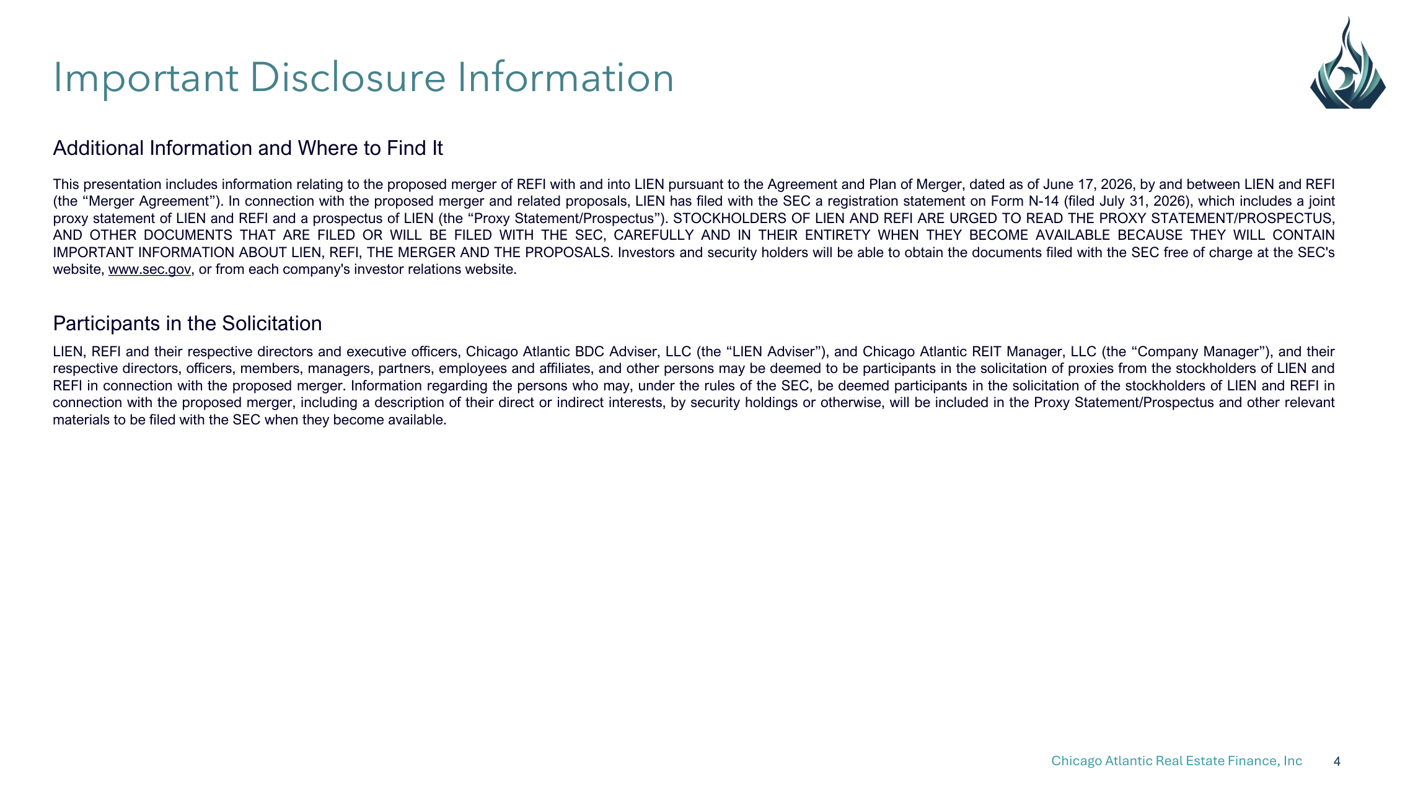
Chicago Atlantic Real Estate Finance, Inc 4 Additional Information and Where to Find It This presentation includes information relating to the proposed merger of REFI with and into LIEN pursuant to the Agreement and Plan of Merger, dated as of June 17, 2026, by and between LIEN and REFI (the "Merger Agreement"). In connection with the proposed merger and related proposals, LIEN has filed with the SEC a registration statement on Form N-14 (filed July 31, 2026), which includes a joint proxy statement of LIEN and REFI and a prospectus of LIEN (the "Proxy Statement/Prospectus"). STOCKHOLDERS OF LIEN AND REFI ARE URGED TO READ THE PROXY STATEMENT/PROSPECTUS, AND OTHER DOCUMENTS THAT ARE FILED OR WILL BE FILED WITH THE SEC, CAREFULLY AND IN THEIR ENTIRETY WHEN THEY BECOME AVAILABLE BECAUSE THEY WILL CONTAIN IMPORTANT INFORMATION ABOUT LIEN, REFI, THE MERGER AND THE PROPOSALS. Investors and security holders will be able to obtain the documents filed with the SEC free of charge at the SEC's website, www.sec.gov, or from each company's investor relations website. Participants in the Solicitation LIEN, REFI and their respective directors and executive officers, Chicago Atlantic BDC Adviser, LLC (the "LIEN Adviser"), and Chicago Atlantic REIT Manager, LLC (the "Company Manager"), and their respective directors, officers, members, managers, partners, employees and affiliates, and other persons may be deemed to be participants in the solicitation of proxies from the stockholders of LIEN and REFI in connection with the proposed merger. Information regarding the persons who may, under the rules of the SEC, be deemed participants in the solicitation of the stockholders of LIEN and REFI in connection with the proposed merger, including a description of their direct or indirect interests, by security holdings or otherwise, will be included in the Proxy Statement/Prospectus and other relevant materials to be filed with the SEC when they become available. Important Disclosure Information

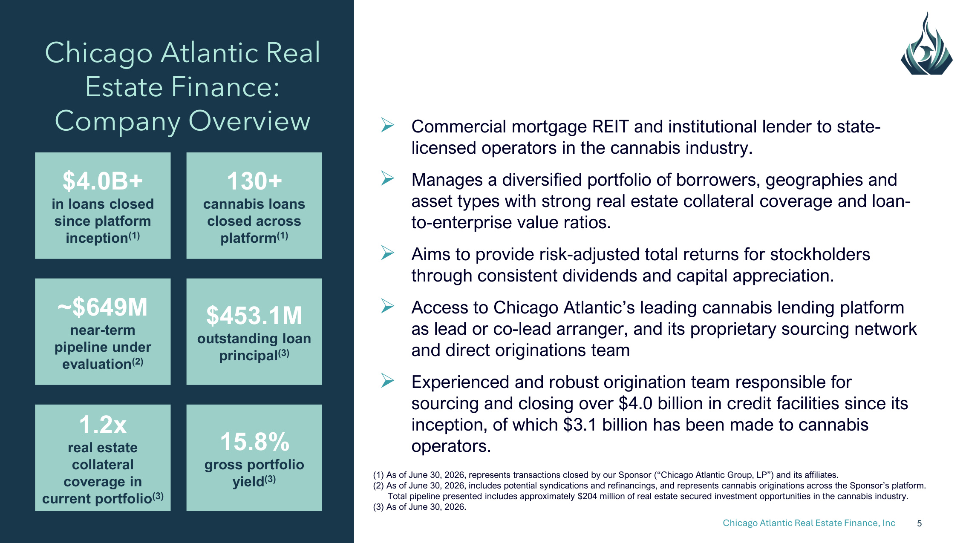
Chicago Atlantic Real Estate Finance, Inc 5 Chicago Atlantic Real Estate Finance: Company Overview Commercial mortgage REIT and institutional lender to state- licensed operators in the cannabis industry. Manages a diversified portfolio of borrowers, geographies and asset types with strong real estate collateral coverage and loan- to-enterprise value ratios. Aims to provide risk-adjusted total returns for stockholders through consistent dividends and capital appreciation. Access to Chicago Atlantic's leading cannabis lending platform as lead or co-lead arranger, and its proprietary sourcing network and direct originations team Experienced and robust origination team responsible for sourcing and closing over $4.0 billion in credit facilities since its inception, of which $3.1 billion has been made to cannabis operators. (1) As of June 30, 2026, represents transactions closed by our Sponsor ("Chicago Atlantic Group, LP") and its affiliates. (2) As of June 30, 2026, includes potential syndications and refinancings, and represents cannabis originations across the Sponsor's platform. Total pipeline presented includes approximately $204 million of real estate secured investment opportunities in the cannabis industry. (3) As of June 30, 2026. ~$649M near-term pipeline under evaluation(2) $4.0B+ in loans closed since platform inception(1) 130+ cannabis loans closed across platform(1) $453.1M outstanding loan principal(3) 15.8% gross portfolio yield(3) 1.2x real estate collateral coverage in current portfolio(3)


Chicago Atlantic Real Estate Finance, Inc 6 (1) Denotes member of Investment Committee John Mazarakis(1) Executive Chairman Tony Cappell(1) Co-CEO Peter Sack(1) Co-CEO Originated over $500mm in cannabis credit transactions Developed and owns over 1mm sf of real estate across 4 states Founded restaurant group with 30+ units and 1,200+ employees MBA from Chicago Booth and BA from University of Delaware Debt investor with 20 years of investment management experience, beginning at Wells Fargo Foothill Completed over 150 deals, comprising over $5bn in total credit MBA from Chicago Booth and BA from University of Wisconsin Former Principal at BC Partners Credit, leading its cannabis practice Former private equity investor, focusing on distressed industrial opportunities MBA from University of Pennsylvania's Wharton School of Business, BA from Yale University, and Fulbright Scholar David Kite(1) President and COO Phil Silverman Chief Financial Officer Over 20 years of experience in investment management and real estate investments Former Partner and COO of Free Market Ventures Former Founder of K&K Capital Management MBA from Chicago Booth and BA from University of Illinois Finance and accounting expert, with 15 years of experience in financial reporting, operations, and internal controls within the asset management industry Former CFO of Chicago Atlantic Group, LP B.S in Finance from Indiana University and holds the CPA designation Industry-Leading Management and Investment Team Deep Cannabis, Credit and Real Estate Expertise With Entrepreneurial Approach 100 YEARS OF COMBINED EXPERIENCE AND OVER $8 BILLION IN REAL ESTATE AND COMMERCIAL CREDIT

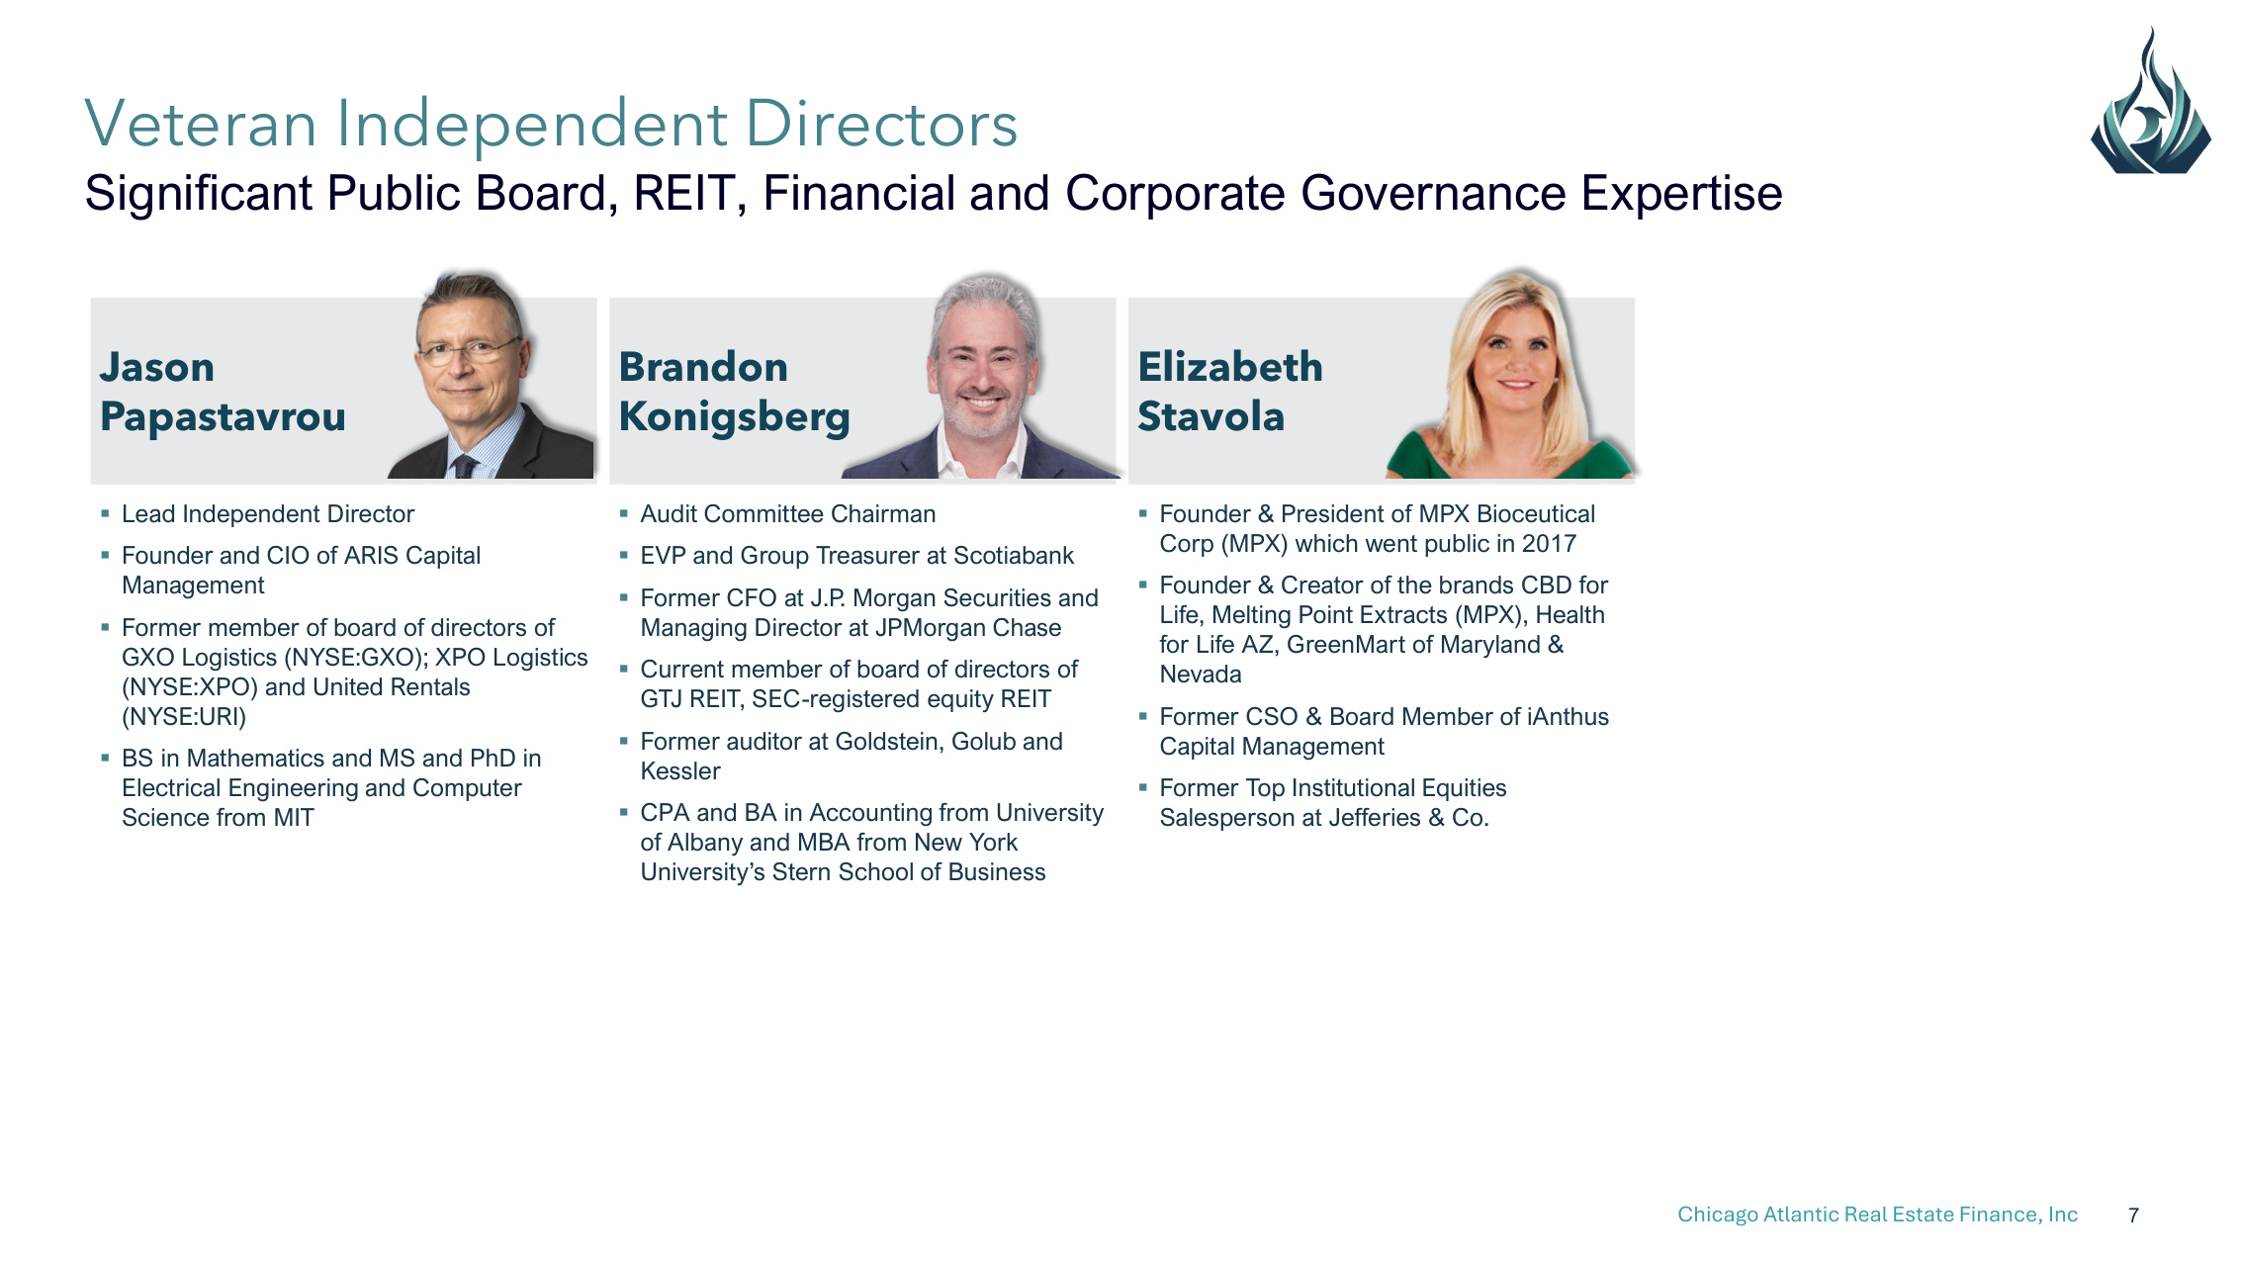
Chicago Atlantic Real Estate Finance, Inc 7 Jason Papastavrou Brandon Konigsberg Elizabeth Stavola Lead Independent Director Founder and CIO of ARIS Capital Management Former member of board of directors of GXO Logistics (NYSE:GXO); XPO Logistics (NYSE:XPO) and United Rentals (NYSE:URI) BS in Mathematics and MS and PhD in Electrical Engineering and Computer Science from MIT Audit Committee Chairman EVP and Group Treasurer at Scotiabank Former CFO at J.P. Morgan Securities and Managing Director at JPMorgan Chase Current member of board of directors of GTJ REIT, SEC-registered equity REIT Former auditor at Goldstein, Golub and Kessler CPA and BA in Accounting from University of Albany and MBA from New York University's Stern School of Business Founder & President of MPX Bioceutical Corp (MPX) which went public in 2017 Founder & Creator of the brands CBD for Life, Melting Point Extracts (MPX), Health for Life AZ, GreenMart of Maryland & Nevada Former CSO & Board Member of iAnthus Capital Management Former Top Institutional Equities Salesperson at Jefferies & Co. Veteran Independent Directors Significant Public Board, REIT, Financial and Corporate Governance Expertise

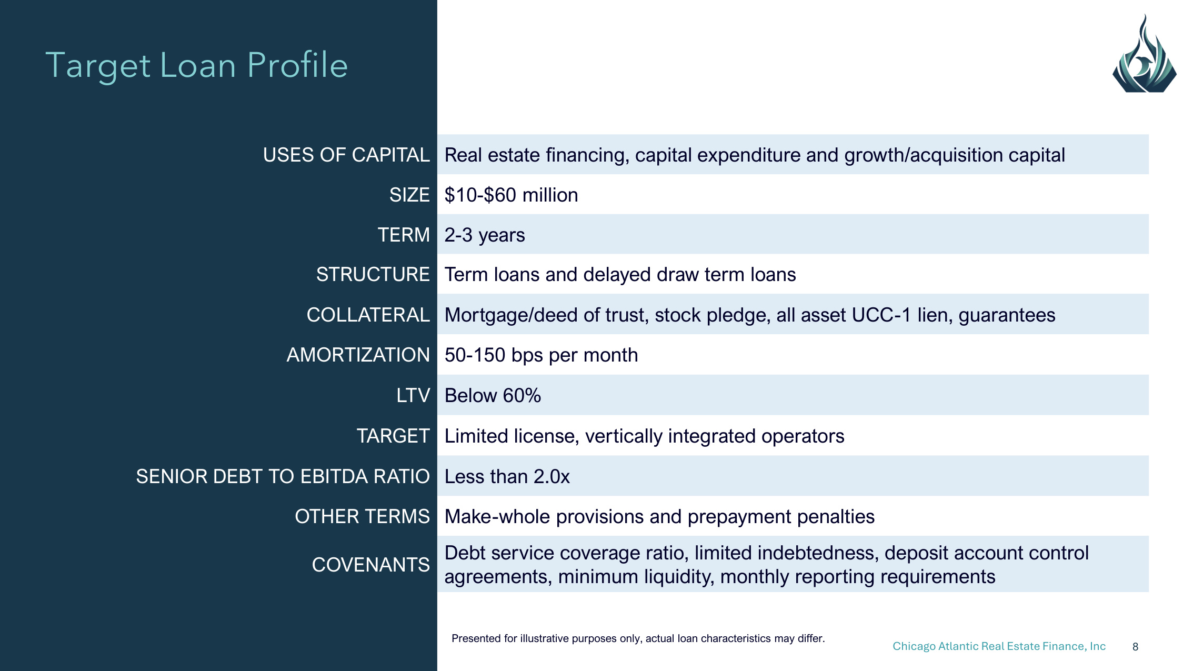
Chicago Atlantic Real Estate Finance, Inc 8 Target Loan Profile Presented for illustrative purposes only, actual loan characteristics may differ. USES OF CAPITAL Real estate financing, capital expenditure and growth/acquisition capital SIZE $10-$60 million TERM 2-3 years STRUCTURE Term loans and delayed draw term loans COLLATERAL Mortgage/deed of trust, stock pledge, all asset UCC-1 lien, guarantees AMORTIZATION 50-150 bps per month LTV Below 60% TARGET Limited license, vertically integrated operators SENIOR DEBT TO EBITDA RATIO Less than 2.0x OTHER TERMS Make-whole provisions and prepayment penalties COVENANTS Debt service coverage ratio, limited indebtedness, deposit account control agreements, minimum liquidity, monthly reporting requirements

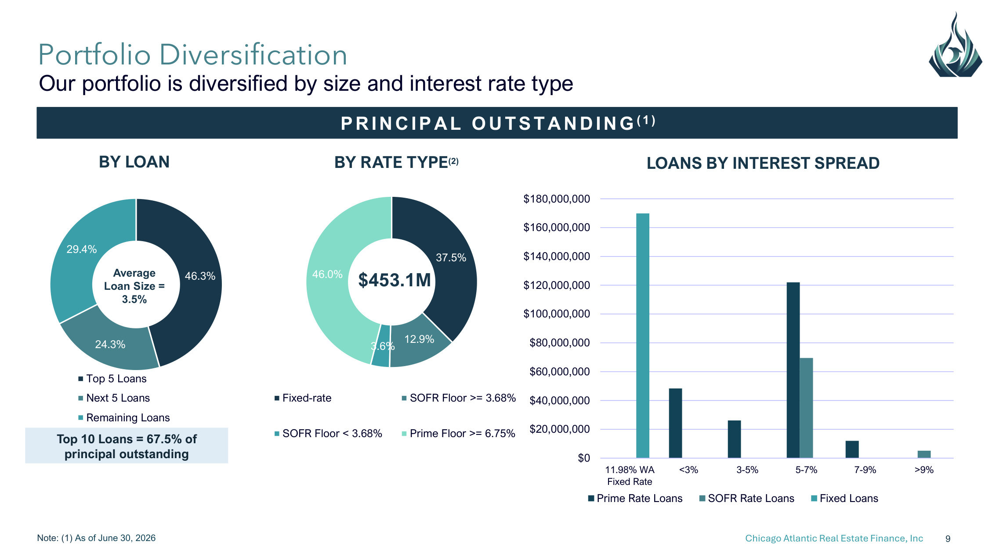
Chicago Atlantic Real Estate Finance, Inc 9 Note: (1) As of June 30, 2026 PR IN C IPA L O U TSTA N D IN G ( 1 ) Portfolio Diversification Our portfolio is diversified by size and interest rate type 46.3% 24.3% 29.4% Top 5 Loans Next 5 Loans Remaining Loans Average Loan Size = 3.5% 37.5% 12.9% 3.6% 46.0% Fixed-rate SOFR Floor >= 3.68% SOFR Floor < 3.68% Prime Floor >= 6.75% BY RATE TYPE(2) LOANS BY INTEREST SPREAD $0 $20,000,000 $40,000,000 $60,000,000 $80,000,000 $100,000,000 $120,000,000 $140,000,000 $160,000,000 $180,000,000 11.98% WA Fixed Rate <3% 3-5% 5-7% 7-9% >9% Prime Rate Loans SOFR Rate Loans Fixed Loans $453.1M Top 10 Loans = 67.5% of principal outstanding BY LOAN

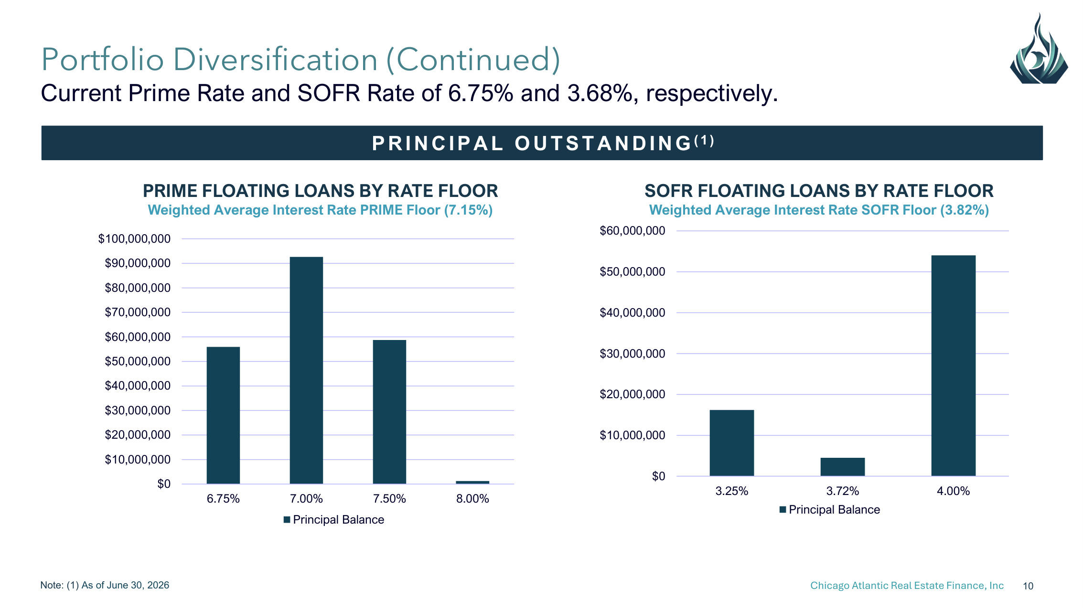
Chicago Atlantic Real Estate Finance, Inc 10 Note: (1) As of June 30, 2026 PR IN C IPA L O U TSTA N D IN G ( 1 ) Portfolio Diversification (Continued) Current Prime Rate and SOFR Rate of 6.75% and 3.68%, respectively. SOFR FLOATING LOANS BY RATE FLOOR Weighted Average Interest Rate SOFR Floor (3.82%) $0 $10,000,000 $20,000,000 $30,000,000 $40,000,000 $50,000,000 $60,000,000 3.25% 3.72% 4.00% Principal Balance $0 $10,000,000 $20,000,000 $30,000,000 $40,000,000 $50,000,000 $60,000,000 $70,000,000 $80,000,000 $90,000,000 $100,000,000 6.75% 7.00% 7.50% 8.00% Principal Balance PRIME FLOATING LOANS BY RATE FLOOR Weighted Average Interest Rate PRIME Floor (7.15%)

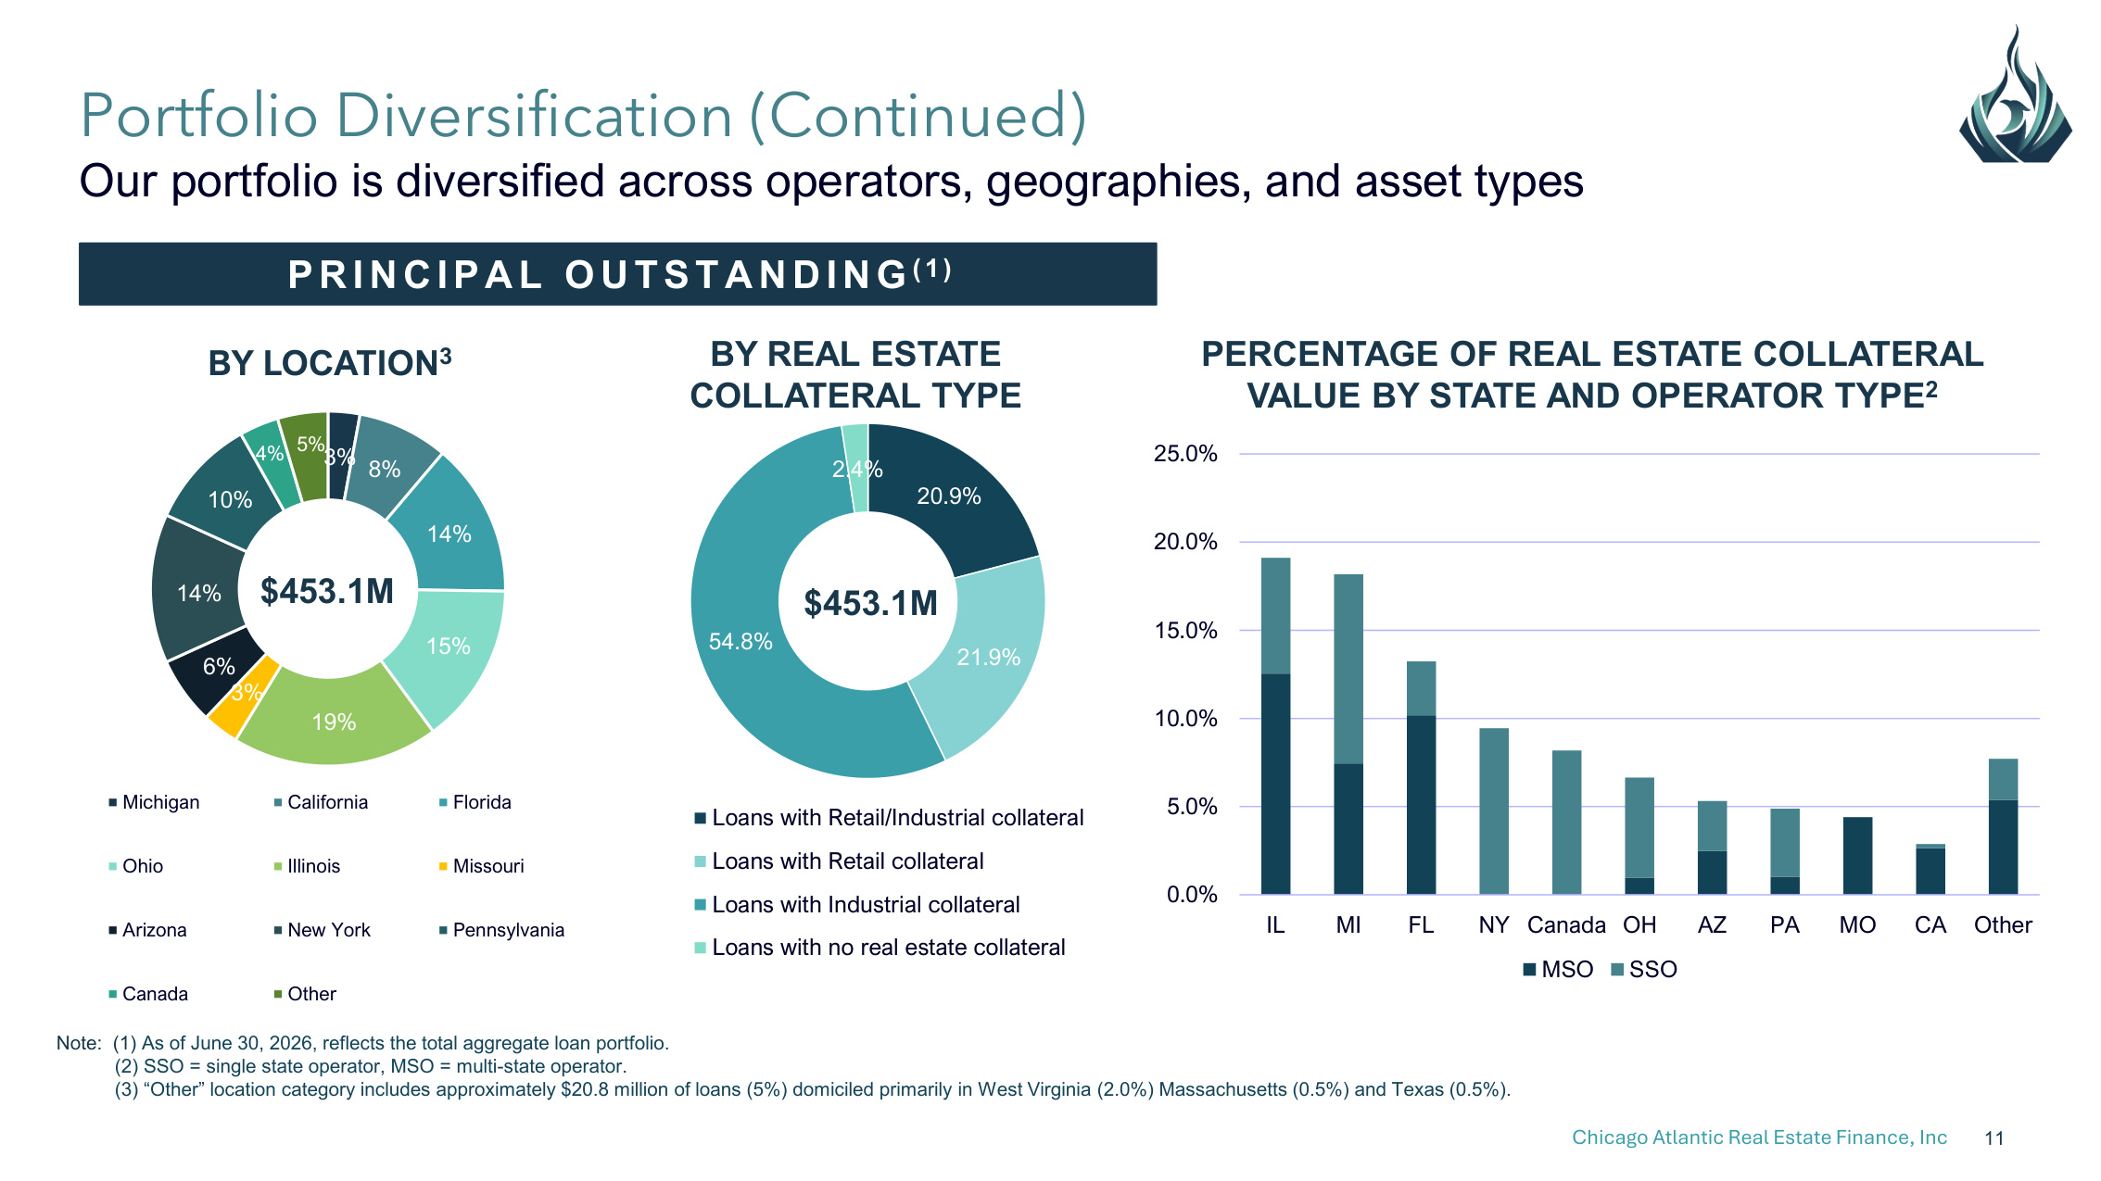
Chicago Atlantic Real Estate Finance, Inc 11 Note: (1) As of June 30, 2026, reflects the total aggregate loan portfolio. (2) SSO = single state operator, MSO = multi-state operator. (3) "Other" location category includes approximately $20.8 million of loans (5%) domiciled primarily in West Virginia (2.0%) Massachusetts (0.5%) and Texas (0.5%). Portfolio Diversification (Continued) Our portfolio is diversified across operators, geographies, and asset types PR IN C IPA L O U TSTA N D IN G ( 1 ) 3% 8% 14% 15% 19% 3% 6% 14% 10% 4% 5% Michigan California Florida Ohio Illinois Missouri Arizona New York Pennsylvania Canada Other $453.1M BY LOCATION3 20.9% 21.9% 54.8% 2.4% Loans with Retail/Industrial collateral Loans with Retail collateral Loans with Industrial collateral Loans with no real estate collateral $453.1M BY REAL ESTATE COLLATERAL TYPE PERCENTAGE OF REAL ESTATE COLLATERAL VALUE BY STATE AND OPERATOR TYPE2 0.0% 5.0% 10.0% 15.0% 20.0% 25.0% IL MI FL NY Canada OH AZ PA MO CA Other MSO SSO

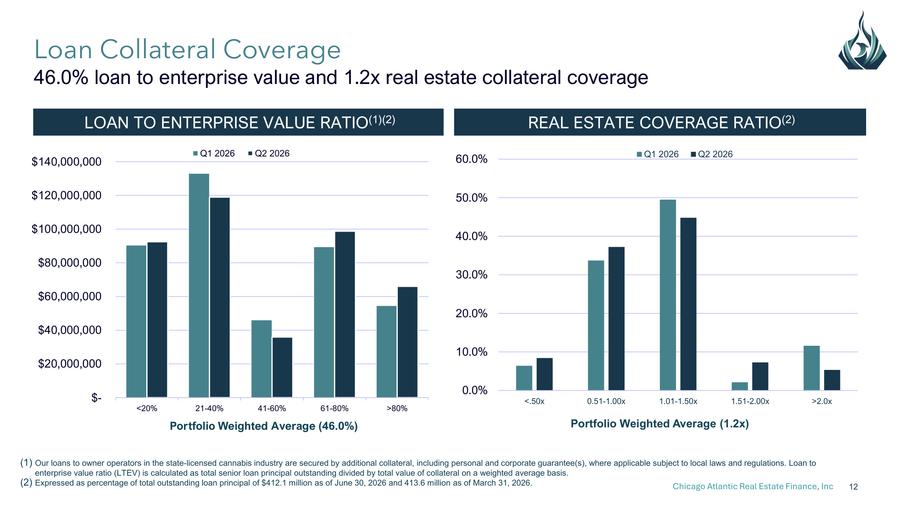
Chicago Atlantic Real Estate Finance, Inc 12 (1) Our loans to owner operators in the state-licensed cannabis industry are secured by additional collateral, including personal and corporate guarantee(s), where applicable subject to local laws and regulations. Loan to enterprise value ratio (LTEV) is calculated as total senior loan principal outstanding divided by total value of collateral on a weighted average basis. (2) Expressed as percentage of total outstanding loan principal of $412.1 million as of June 30, 2026 and 413.6 million as of March 31, 2026. LOAN TO ENTERPRISE VALUE RATIO(1)(2) REAL ESTATE COVERAGE RATIO(2) Loan Collateral Coverage 46.0% loan to enterprise value and 1.2x real estate collateral coverage $- $20,000,000 $40,000,000 $60,000,000 $80,000,000 $100,000,000 $120,000,000 $140,000,000 <20% 21-40% 41-60% 61-80% >80% Q1 2026 Q2 2026 Portfolio Weighted Average (46.0%) 0.0% 10.0% 20.0% 30.0% 40.0% 50.0% 60.0% <.50x 0.51-1.00x 1.01-1.50x 1.51-2.00x >2.0x Q1 2026 Q2 2026 Portfolio Weighted Average (1.2x)

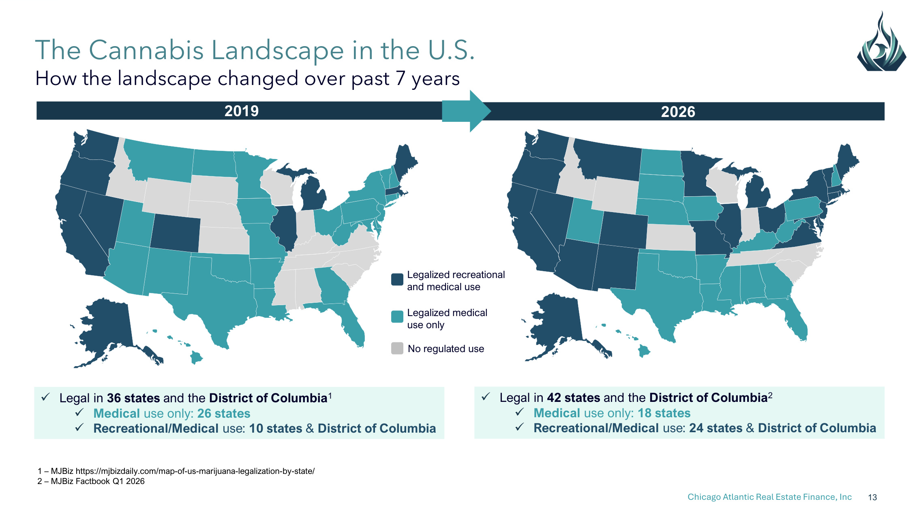
Chicago Atlantic Real Estate Finance, Inc 13 The Cannabis Landscape in the U.S. How the landscape changed over past 7 years 2019 2026 1 – MJBiz https://mjbizdaily.com/map-of-us-marijuana-legalization-by-state/ 2 – MJBiz Factbook Q1 2026 Legal in 42 states and the District of Columbia2 Medical use only: 18 states Recreational/Medical use: 24 states & District of Columbia Legal in 36 states and the District of Columbia1 Medical use only: 26 states Recreational/Medical use: 10 states & District of Columbia No regulated use Legalized recreational and medical use Legalized medical use only

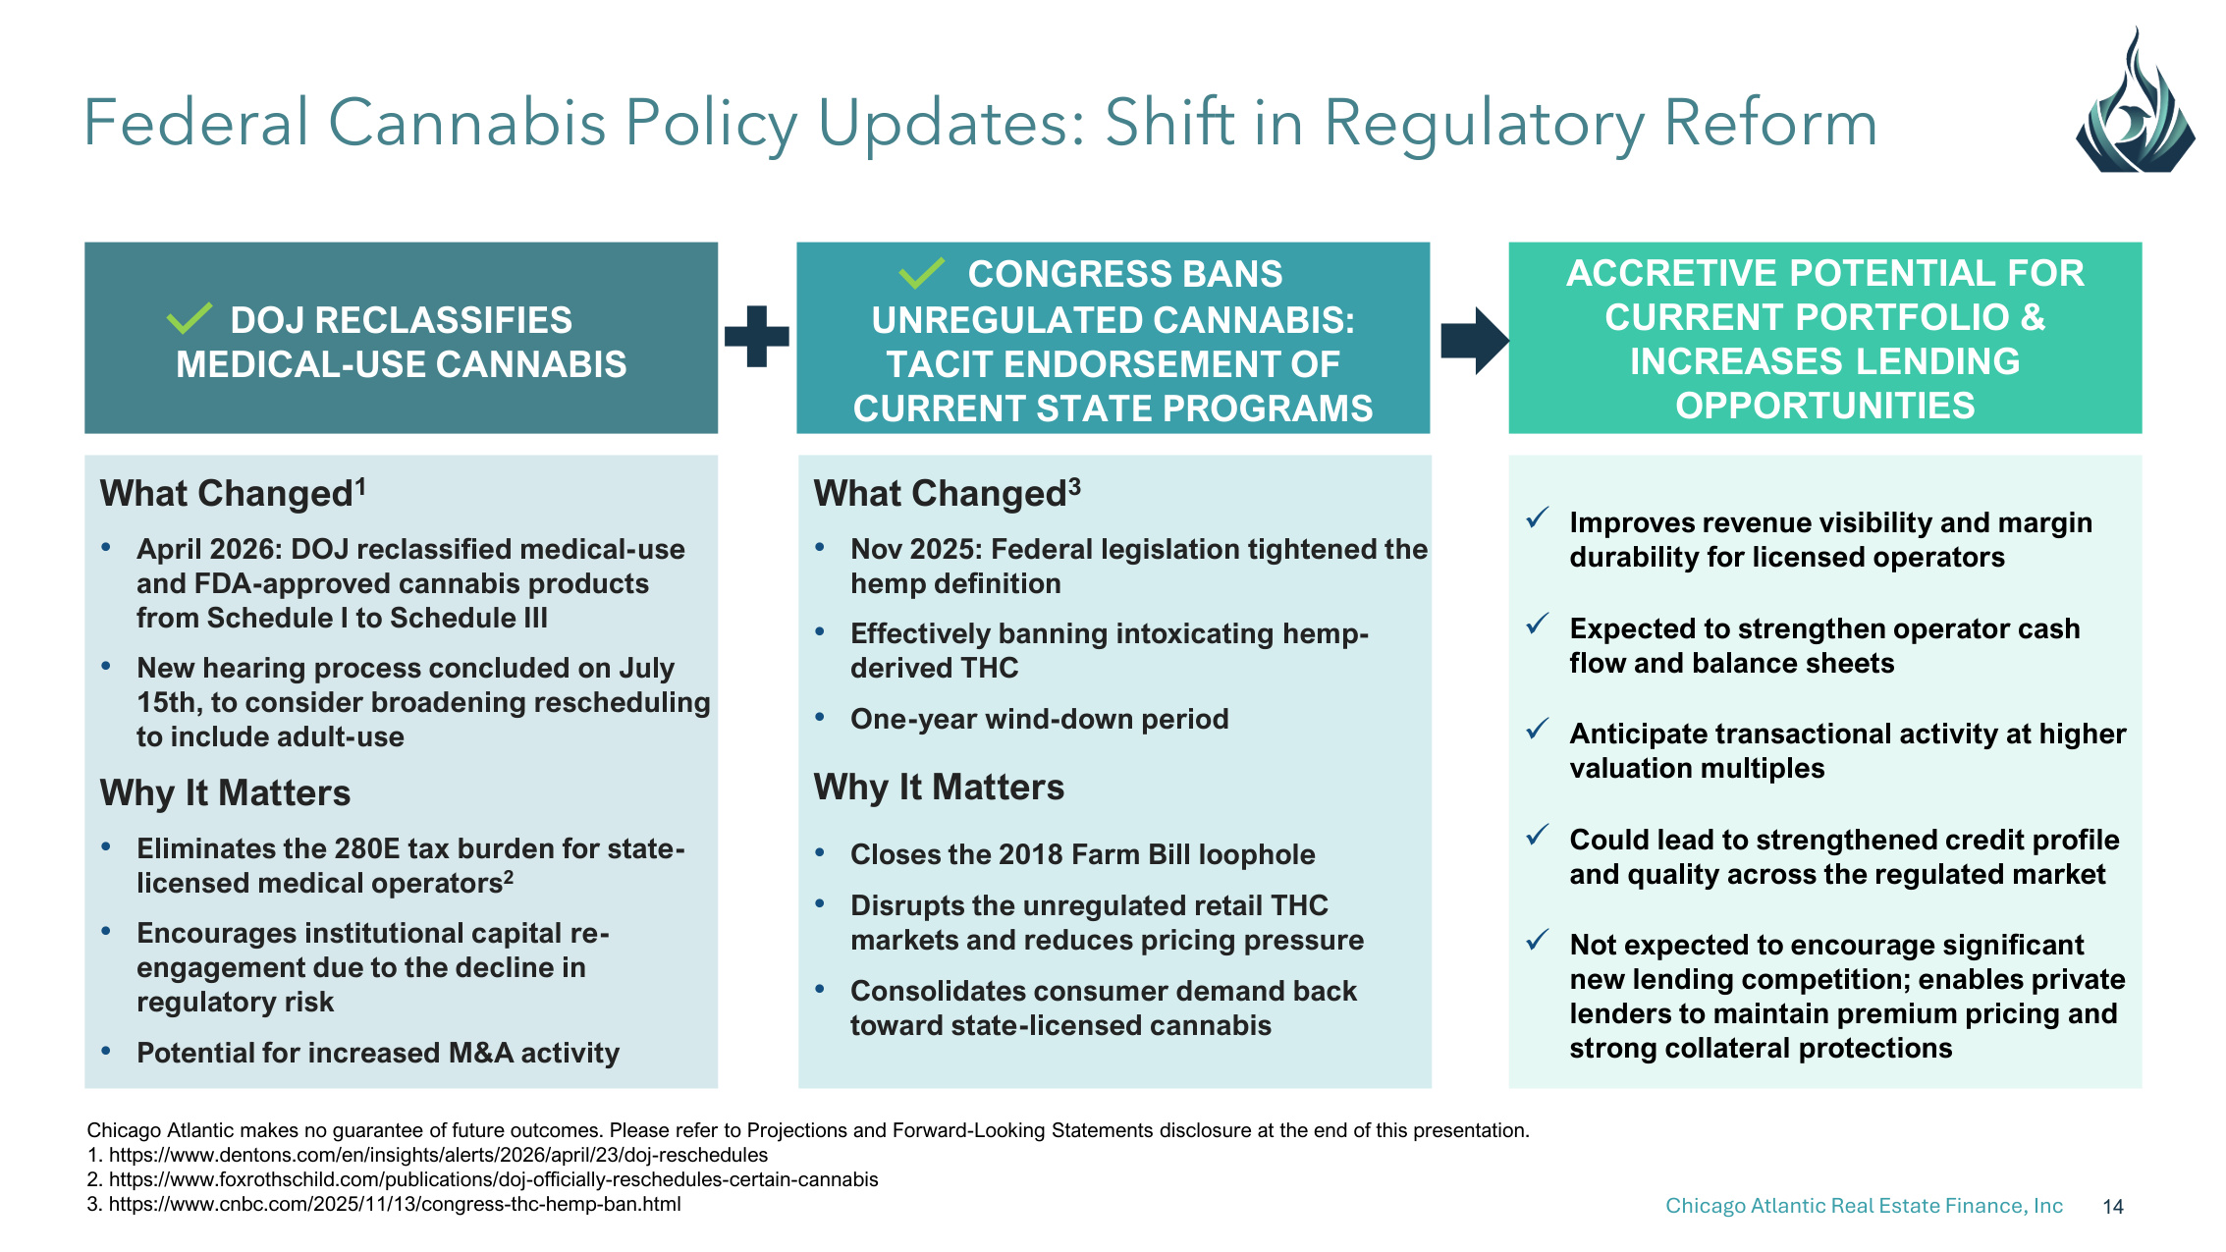
Chicago Atlantic Real Estate Finance, Inc 14 Federal Cannabis Policy Updates: Shift in Regulatory Reform Chicago Atlantic makes no guarantee of future outcomes. Please refer to Projections and Forward-Looking Statements disclosure at the end of this presentation. 1. https://www.dentons.com/en/insights/alerts/2026/april/23/doj-reschedules 2. https://www.foxrothschild.com/publications/doj-officially-reschedules-certain-cannabis 3. https://www.cnbc.com/2025/11/13/congress-thc-hemp-ban.html DOJ RECLASSIFIES MEDICAL-USE CANNABIS CONGRESS BANS UNREGULATED CANNABIS: TACIT ENDORSEMENT OF CURRENT STATE PROGRAMS What Changed1 • April 2026: DOJ reclassified medical-use and FDA-approved cannabis products from Schedule I to Schedule III • New hearing process concluded on July 15th, to consider broadening rescheduling to include adult-use Why It Matters • Eliminates the 280E tax burden for state- licensed medical operators2 • Encourages institutional capital re- engagement due to the decline in regulatory risk • Potential for increased M&A activity What Changed3 • Nov 2025: Federal legislation tightened the hemp definition • Effectively banning intoxicating hemp- derived THC • One-year wind-down period Why It Matters • Closes the 2018 Farm Bill loophole • Disrupts the unregulated retail THC markets and reduces pricing pressure • Consolidates consumer demand back toward state-licensed cannabis ACCRETIVE POTENTIAL FOR CURRENT PORTFOLIO & INCREASES LENDING OPPORTUNITIES Improves revenue visibility and margin durability for licensed operators Expected to strengthen operator cash flow and balance sheets Anticipate transactional activity at higher valuation multiples Could lead to strengthened credit profile and quality across the regulated market Not expected to encourage significant new lending competition; enables private lenders to maintain premium pricing and strong collateral protections

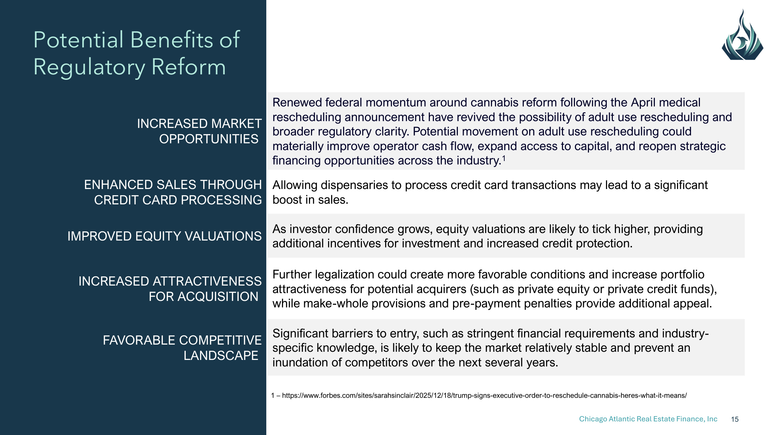
Chicago Atlantic Real Estate Finance, Inc 15 Potential Benefits of Regulatory Reform INCREASED MARKET OPPORTUNITIES Renewed federal momentum around cannabis reform following the April medical rescheduling announcement have revived the possibility of adult use rescheduling and broader regulatory clarity. Potential movement on adult use rescheduling could materially improve operator cash flow, expand access to capital, and reopen strategic financing opportunities across the industry.1 ENHANCED SALES THROUGH CREDIT CARD PROCESSING Allowing dispensaries to process credit card transactions may lead to a significant boost in sales. IMPROVED EQUITY VALUATIONS As investor confidence grows, equity valuations are likely to tick higher, providing additional incentives for investment and increased credit protection. INCREASED ATTRACTIVENESS FOR ACQUISITION Further legalization could create more favorable conditions and increase portfolio attractiveness for potential acquirers (such as private equity or private credit funds), while make-whole provisions and pre-payment penalties provide additional appeal. FAVORABLE COMPETITIVE LANDSCAPE Significant barriers to entry, such as stringent financial requirements and industry- specific knowledge, is likely to keep the market relatively stable and prevent an inundation of competitors over the next several years. 1 – https://www.forbes.com/sites/sarahsinclair/2025/12/18/trump-signs-executive-order-to-reschedule-cannabis-heres-what-it-means/

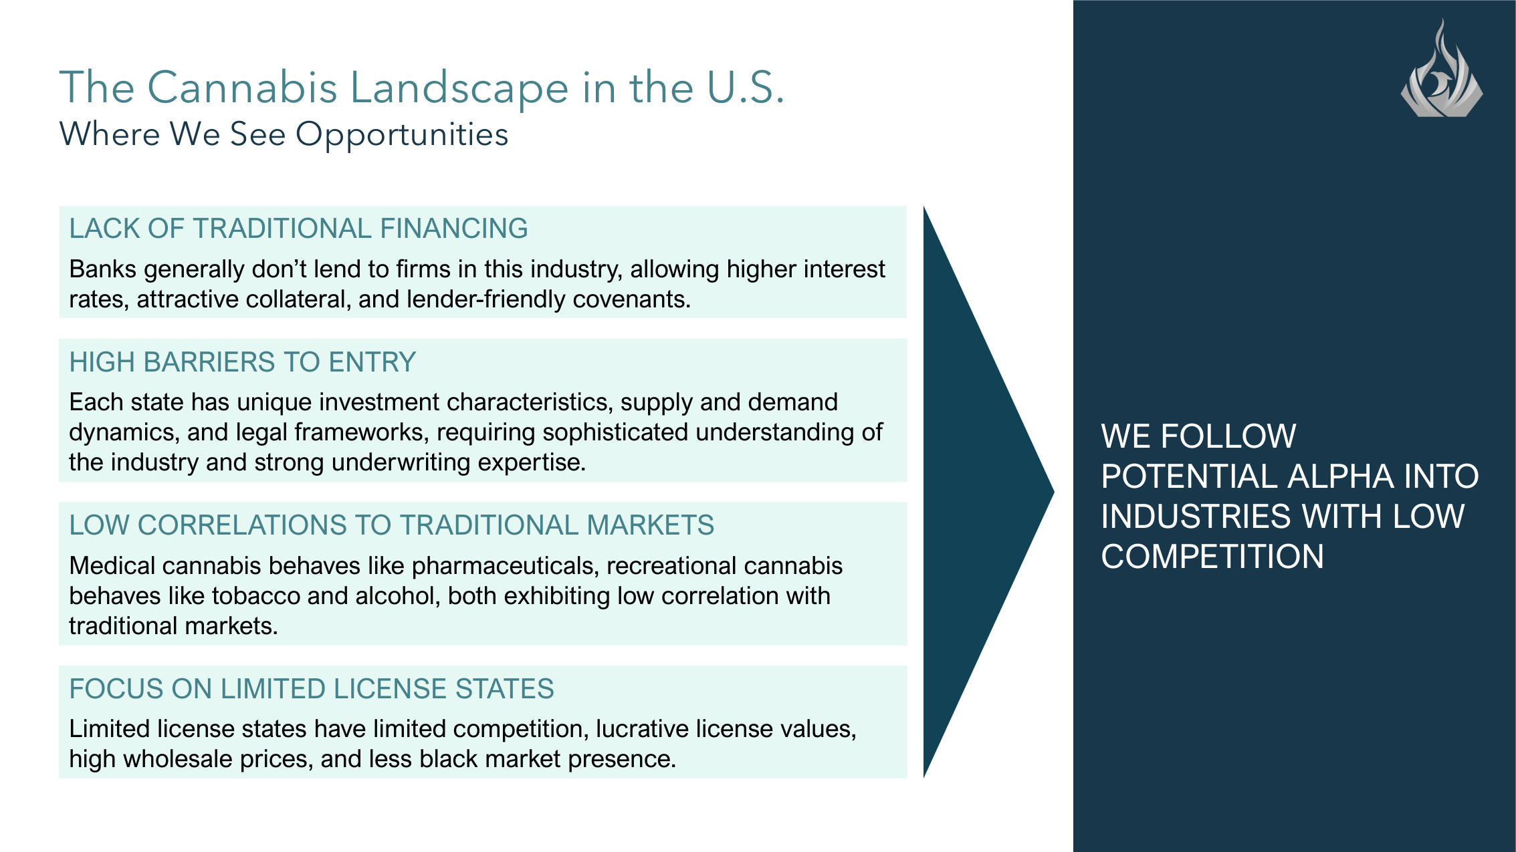
Chicago Atlantic Real Estate Finance, Inc 16 The Cannabis Landscape in the U.S. Where We See Opportunities WE FOLLOW POTENTIAL ALPHA INTO INDUSTRIES WITH LOW COMPETITION LACK OF TRADITIONAL FINANCING Banks generally don't lend to firms in this industry, allowing higher interest rates, attractive collateral, and lender-friendly covenants. LOW CORRELATIONS TO TRADITIONAL MARKETS Medical cannabis behaves like pharmaceuticals, recreational cannabis behaves like tobacco and alcohol, both exhibiting low correlation with traditional markets. HIGH BARRIERS TO ENTRY Each state has unique investment characteristics, supply and demand dynamics, and legal frameworks, requiring sophisticated understanding of the industry and strong underwriting expertise. FOCUS ON LIMITED LICENSE STATES Limited license states have limited competition, lucrative license values, high wholesale prices, and less black market presence.

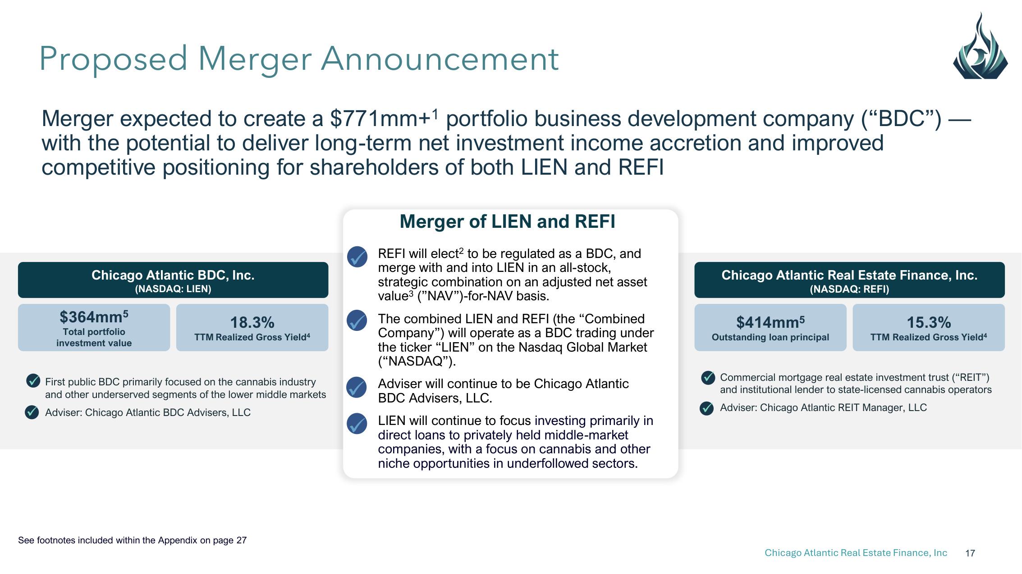
Chicago Atlantic Real Estate Finance, Inc 17 Merger expected to create a $771mm+1 portfolio business development company ("BDC") — with the potential to deliver long-term net investment income accretion and improved competitive positioning for shareholders of both LIEN and REFI Proposed Merger Announcement Commercial mortgage real estate investment trust ("REIT") and institutional lender to state-licensed cannabis operators Adviser: Chicago Atlantic REIT Manager, LLC Chicago Atlantic Real Estate Finance, Inc. (NASDAQ: REFI) $414mm5 Outstanding loan principal 15.3% TTM Realized Gross Yield4 First public BDC primarily focused on the cannabis industry and other underserved segments of the lower middle markets Adviser: Chicago Atlantic BDC Advisers, LLC Chicago Atlantic BDC, Inc. (NASDAQ: LIEN) $364mm5 Total portfolio investment value 18.3% TTM Realized Gross Yield4 a REFI will elect2 to be regulated as a BDC, and merge with and into LIEN in an all-stock, strategic combination on an adjusted net asset value3 ("NAV")-for-NAV basis. The combined LIEN and REFI (the "Combined Company") will operate as a BDC trading under the ticker "LIEN" on the Nasdaq Global Market ("NASDAQ"). Adviser will continue to be Chicago Atlantic BDC Advisers, LLC. LIEN will continue to focus investing primarily in direct loans to privately held middle-market companies, with a focus on cannabis and other niche opportunities in underfollowed sectors. Merger of LIEN and REFI See footnotes included within the Appendix on page 27

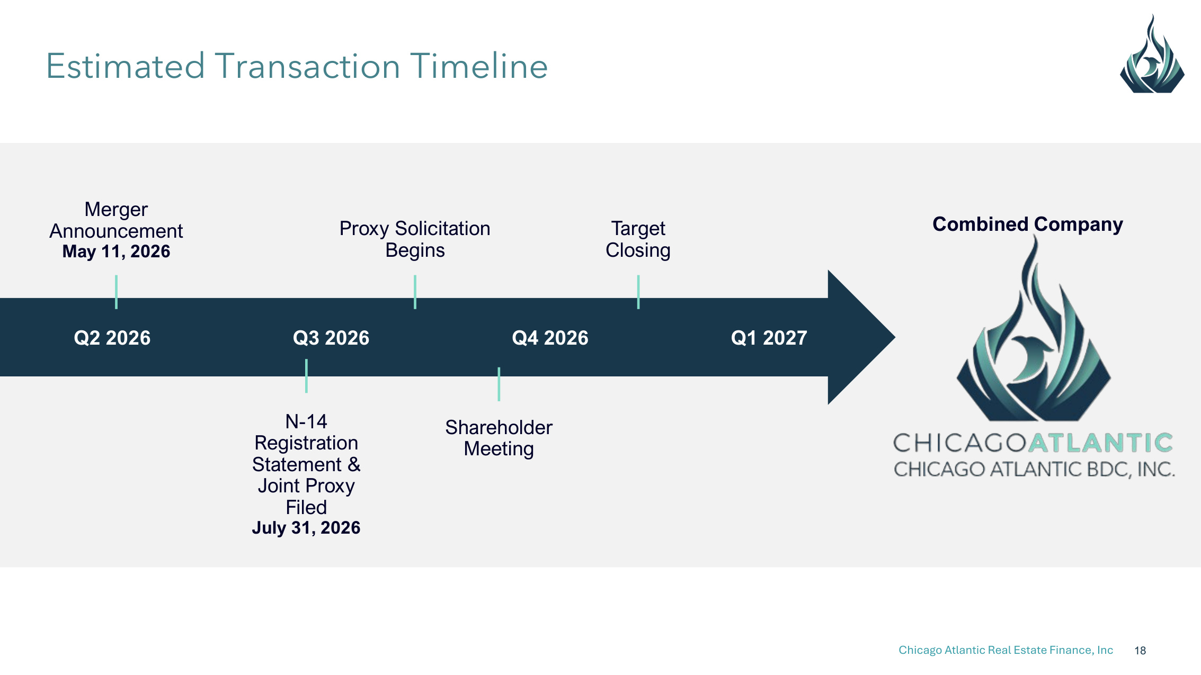
Chicago Atlantic Real Estate Finance, Inc 18 Q2 2026 Merger Announcement May 11, 2026 Q3 2026 Q4 2026 Target Closing Proxy Solicitation Begins Combined Company Q1 2027 Estimated Transaction Timeline N-14 Registration Statement & Joint Proxy Filed July 31, 2026 Shareholder Meeting

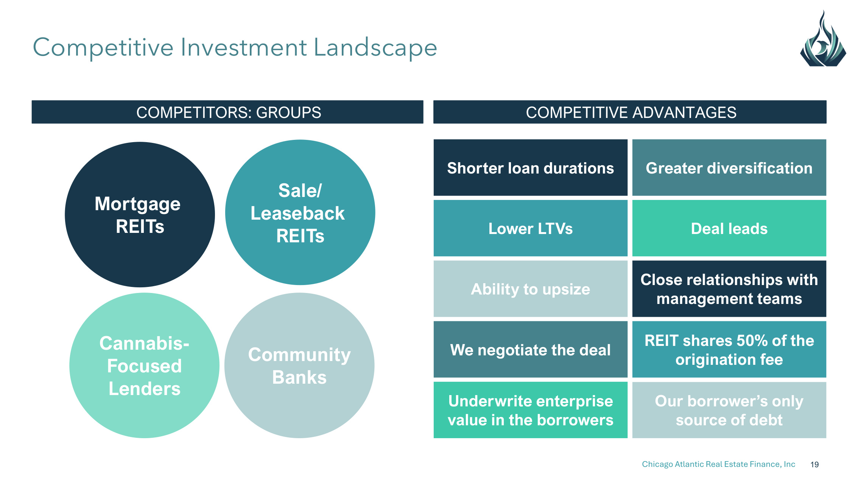
Chicago Atlantic Real Estate Finance, Inc 19 COMPETITORS: GROUPS COMPETITIVE ADVANTAGES Competitive Investment Landscape Mortgage REITs Sale/ Leaseback REITs Cannabis- Focused Lenders Community Banks Shorter loan durations Greater diversification Lower LTVs Deal leads Ability to upsize Close relationships with management teams We negotiate the deal REIT shares 50% of the origination fee Underwrite enterprise value in the borrowers Our borrower's only source of debt

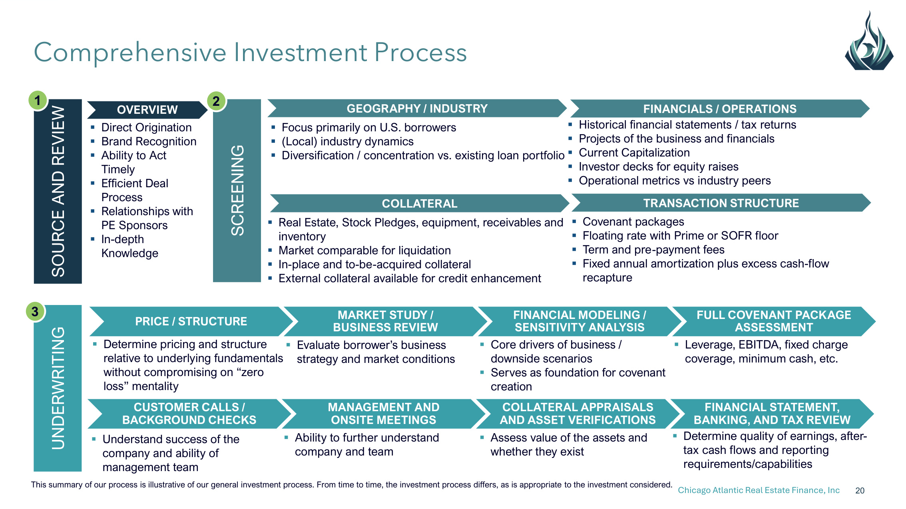
Chicago Atlantic Real Estate Finance, Inc 20 COLLATERAL APPRAISALS AND ASSET VERIFICATIONS MANAGEMENT AND ONSITE MEETINGS Comprehensive Investment Process SOURCE AND REVIEW 1 Direct Origination Brand Recognition Ability to Act Timely Efficient Deal Process Relationships with PE Sponsors In-depth Knowledge SCREENING 2 FINANCIALS / OPERATIONS COLLATERAL TRANSACTION STRUCTURE GEOGRAPHY / INDUSTRY Focus primarily on U.S. borrowers (Local) industry dynamics Diversification / concentration vs. existing loan portfolio Historical financial statements / tax returns Projects of the business and financials Current Capitalization Investor decks for equity raises Operational metrics vs industry peers Real Estate, Stock Pledges, equipment, receivables and inventory Market comparable for liquidation In-place and to-be-acquired collateral External collateral available for credit enhancement Covenant packages Floating rate with Prime or SOFR floor Term and pre-payment fees Fixed annual amortization plus excess cash-flow recapture UNDERWRITING 3 MARKET STUDY / BUSINESS REVIEW PRICE / STRUCTURE FINANCIAL MODELING / SENSITIVITY ANALYSIS FULL COVENANT PACKAGE ASSESSMENT Determine pricing and structure relative to underlying fundamentals without compromising on "zero loss" mentality Evaluate borrower's business strategy and market conditions Core drivers of business / downside scenarios Serves as foundation for covenant creation Leverage, EBITDA, fixed charge coverage, minimum cash, etc. Understand success of the company and ability of management team Ability to further understand company and team Assess value of the assets and whether they exist Determine quality of earnings, after- tax cash flows and reporting requirements/capabilities OVERVIEW CUSTOMER CALLS / BACKGROUND CHECKS FINANCIAL STATEMENT, BANKING, AND TAX REVIEW This summary of our process is illustrative of our general investment process. From time to time, the investment process differs, as is appropriate to the investment considered.

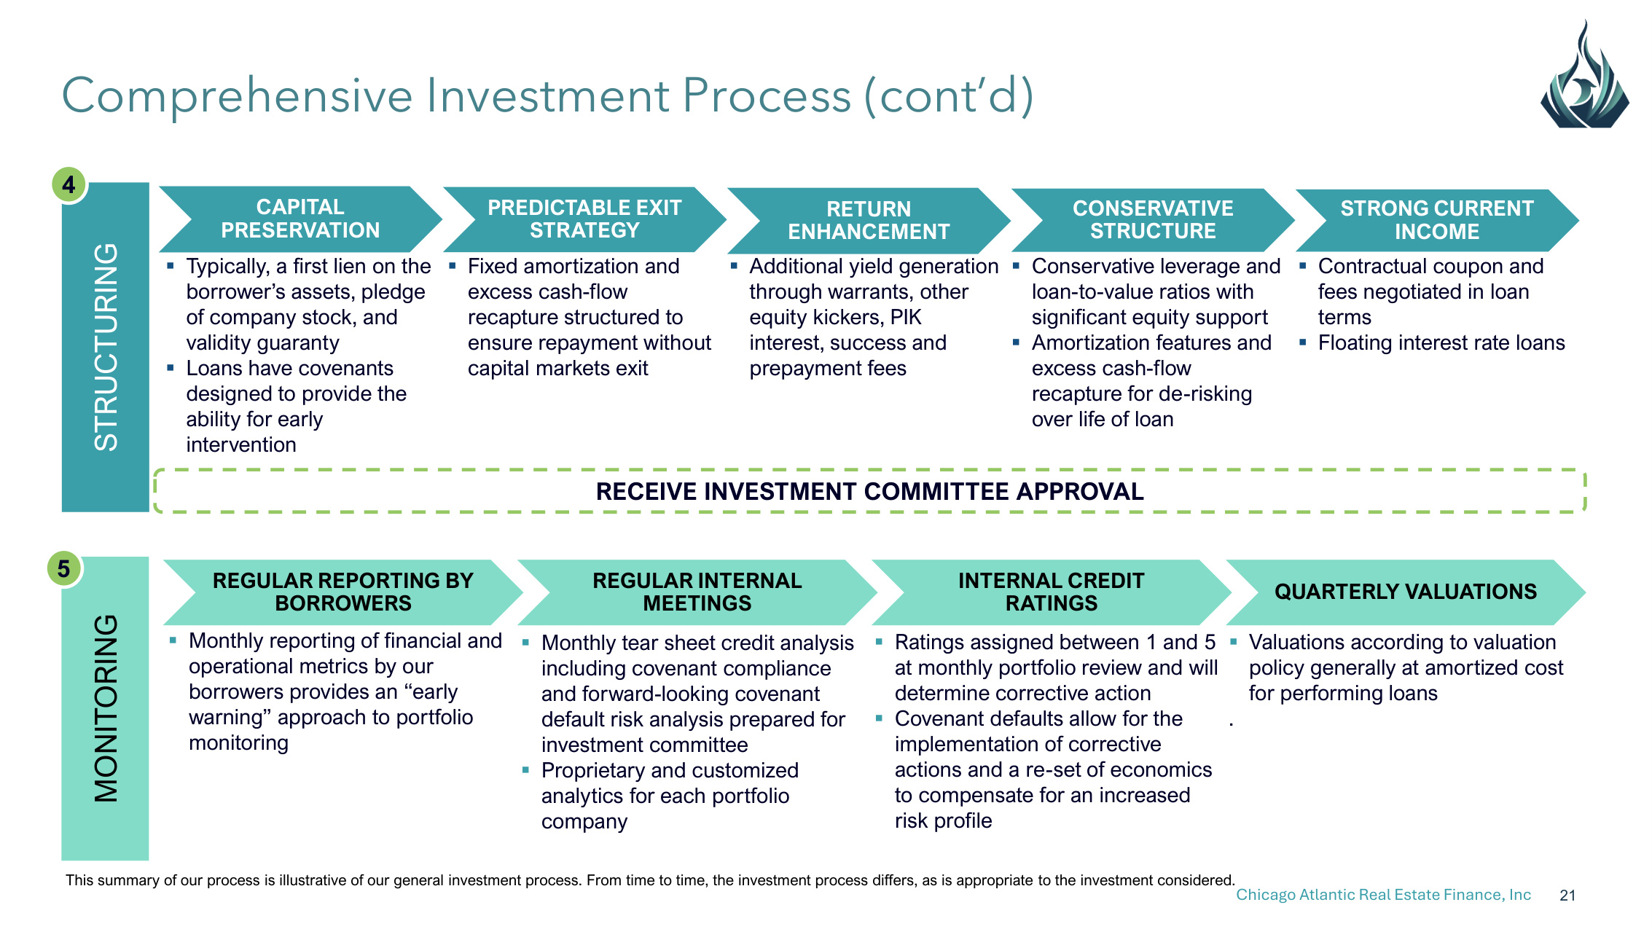
Chicago Atlantic Real Estate Finance, Inc 21 Comprehensive Investment Process (cont'd) STRUCTURING 4 Typically, a first lien on the borrower's assets, pledge of company stock, and validity guaranty Loans have covenants designed to provide the ability for early intervention MONITORING 5 REGULAR INTERNAL MEETINGS REGULAR REPORTING BY BORROWERS INTERNAL CREDIT RATINGS QUARTERLY VALUATIONS Monthly reporting of financial and operational metrics by our borrowers provides an "early warning" approach to portfolio monitoring Monthly tear sheet credit analysis including covenant compliance and forward-looking covenant default risk analysis prepared for investment committee Proprietary and customized analytics for each portfolio company Ratings assigned between 1 and 5 at monthly portfolio review and will determine corrective action Covenant defaults allow for the implementation of corrective actions and a re-set of economics to compensate for an increased risk profile Valuations according to valuation policy generally at amortized cost for performing loans . CAPITAL PRESERVATION PREDICTABLE EXIT STRATEGY RETURN ENHANCEMENT CONSERVATIVE STRUCTURE STRONG CURRENT INCOME Contractual coupon and fees negotiated in loan terms Floating interest rate loans Conservative leverage and loan-to-value ratios with significant equity support Amortization features and excess cash-flow recapture for de-risking over life of loan Additional yield generation through warrants, other equity kickers, PIK interest, success and prepayment fees Fixed amortization and excess cash-flow recapture structured to ensure repayment without capital markets exit RECEIVE INVESTMENT COMMITTEE APPROVAL This summary of our process is illustrative of our general investment process. From time to time, the investment process differs, as is appropriate to the investment considered.


Appendix Financial Overview For the three months ended June 30, 2026

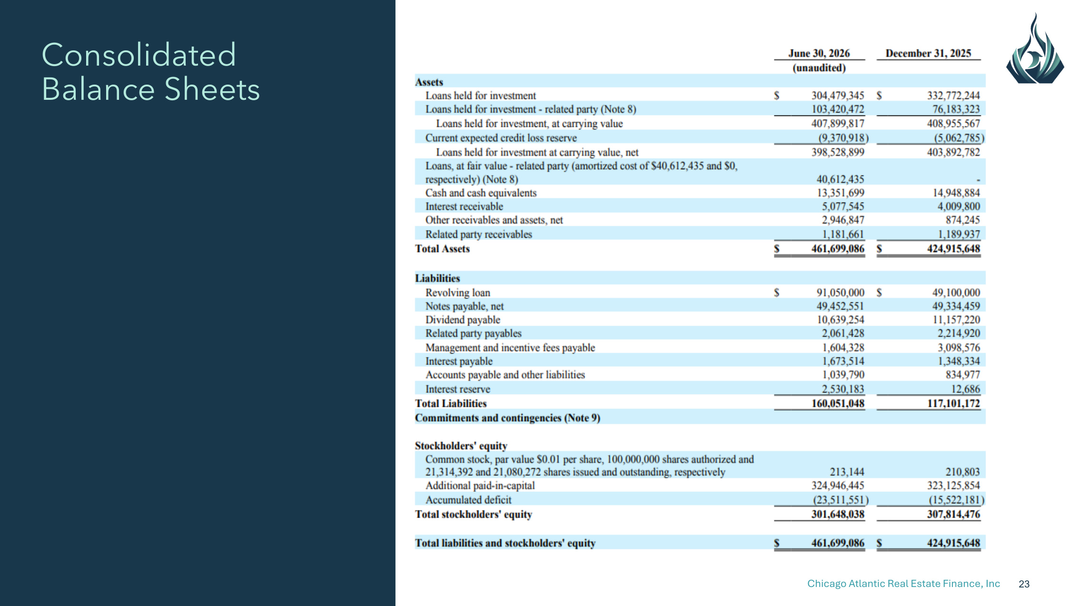
Chicago Atlantic Real Estate Finance, Inc 23 Consolidated Balance Sheets

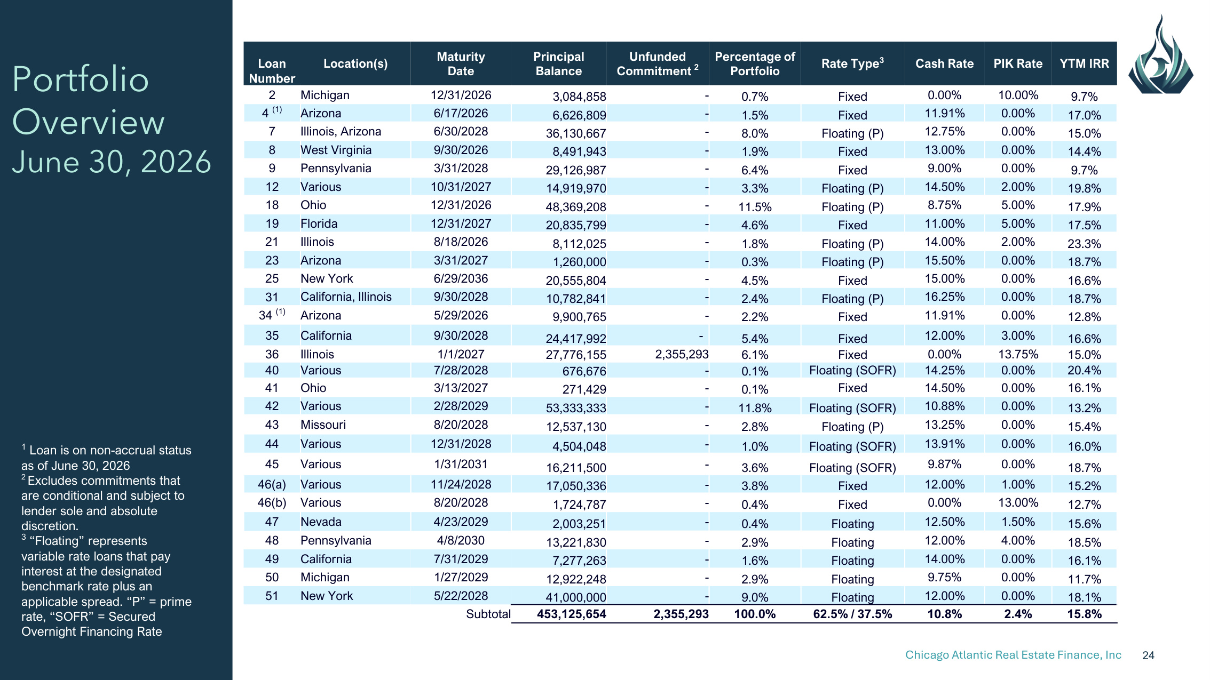
Chicago Atlantic Real Estate Finance, Inc 24 1 Loan is on non-accrual status as of June 30, 2026 2 Excludes commitments that are conditional and subject to lender sole and absolute discretion. 3 "Floating" represents variable rate loans that pay interest at the designated benchmark rate plus an applicable spread. "P" = prime rate, "SOFR" = Secured Overnight Financing Rate Portfolio Overview June 30, 2026 Loan Number Location(s) Maturity Date Principal Balance Unfunded Commitment 2 Percentage of Portfolio Rate Type3 Cash Rate PIK Rate YTM IRR 2 Michigan 12/31/2026 3,084,858 - 0.7% Fixed 0.00% 10.00% 9.7% 4 (1) Arizona 6/17/2026 6,626,809 - 1.5% Fixed 11.91% 0.00% 17.0% 7 Illinois, Arizona 6/30/2028 36,130,667 - 8.0% Floating (P) 12.75% 0.00% 15.0% 8 West Virginia 9/30/2026 8,491,943 - 1.9% Fixed 13.00% 0.00% 14.4% 9 Pennsylvania 3/31/2028 29,126,987 - 6.4% Fixed 9.00% 0.00% 9.7% 12 Various 10/31/2027 14,919,970 - 3.3% Floating (P) 14.50% 2.00% 19.8% 18 Ohio 12/31/2026 48,369,208 - 11.5% Floating (P) 8.75% 5.00% 17.9% 19 Florida 12/31/2027 20,835,799 - 4.6% Fixed 11.00% 5.00% 17.5% 21 Illinois 8/18/2026 8,112,025 - 1.8% Floating (P) 14.00% 2.00% 23.3% 23 Arizona 3/31/2027 1,260,000 - 0.3% Floating (P) 15.50% 0.00% 18.7% 25 New York 6/29/2036 20,555,804 - 4.5% Fixed 15.00% 0.00% 16.6% 31 California, Illinois 9/30/2028 10,782,841 - 2.4% Floating (P) 16.25% 0.00% 18.7% 34 (1) Arizona 5/29/2026 9,900,765 - 2.2% Fixed 11.91% 0.00% 12.8% 35 California 9/30/2028 24,417,992 - 5.4% Fixed 12.00% 3.00% 16.6% 36 Illinois 1/1/2027 27,776,155 2,355,293 6.1% Fixed 0.00% 13.75% 15.0% 40 Various 7/28/2028 676,676 - 0.1% Floating (SOFR) 14.25% 0.00% 20.4% 41 Ohio 3/13/2027 271,429 - 0.1% Fixed 14.50% 0.00% 16.1% 42 Various 2/28/2029 53,333,333 - 11.8% Floating (SOFR) 10.88% 0.00% 13.2% 43 Missouri 8/20/2028 12,537,130 - 2.8% Floating (P) 13.25% 0.00% 15.4% 44 Various 12/31/2028 4,504,048 - 1.0% Floating (SOFR) 13.91% 0.00% 16.0% 45 Various 1/31/2031 16,211,500 - 3.6% Floating (SOFR) 9.87% 0.00% 18.7% 46(a) Various 11/24/2028 17,050,336 - 3.8% Fixed 12.00% 1.00% 15.2% 46(b) Various 8/20/2028 1,724,787 - 0.4% Fixed 0.00% 13.00% 12.7% 47 Nevada 4/23/2029 2,003,251 - 0.4% Floating 12.50% 1.50% 15.6% 48 Pennsylvania 4/8/2030 13,221,830 - 2.9% Floating 12.00% 4.00% 18.5% 49 California 7/31/2029 7,277,263 - 1.6% Floating 14.00% 0.00% 16.1% 50 Michigan 1/27/2029 12,922,248 - 2.9% Floating 9.75% 0.00% 11.7% 51 New York 5/22/2028 41,000,000 - 9.0% Floating 12.00% 0.00% 18.1% Subtotal 453,125,654 2,355,293 100.0% 62.5% / 37.5% 10.8% 2.4% 15.8%

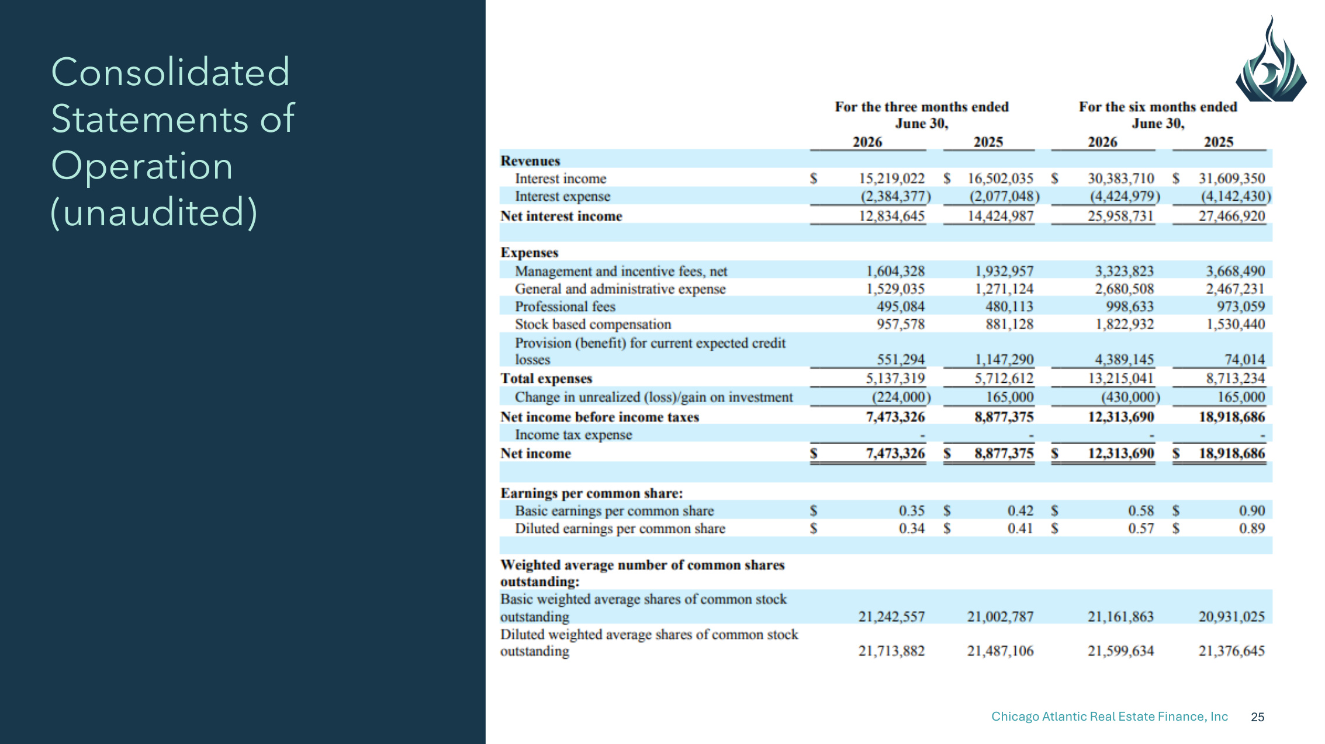
Chicago Atlantic Real Estate Finance, Inc 25 Consolidated Statements of Operation (unaudited)

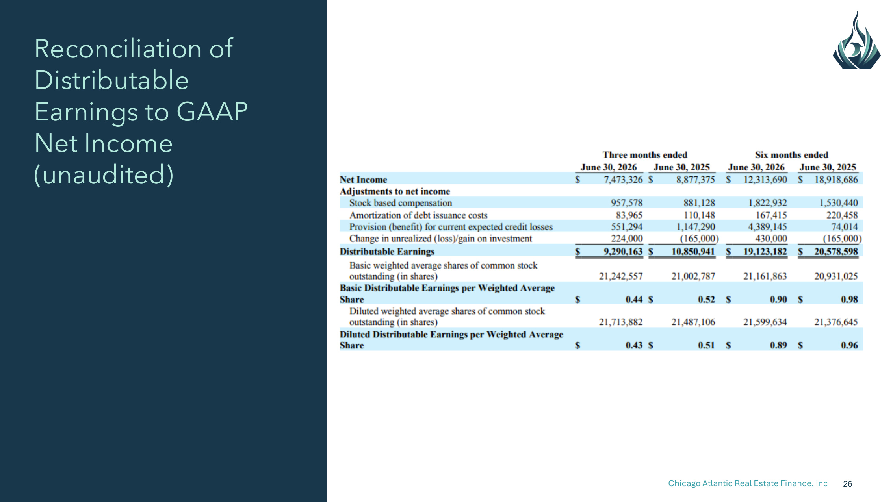
Chicago Atlantic Real Estate Finance, Inc 26 Reconciliation of Distributable Earnings to GAAP Net Income (unaudited)

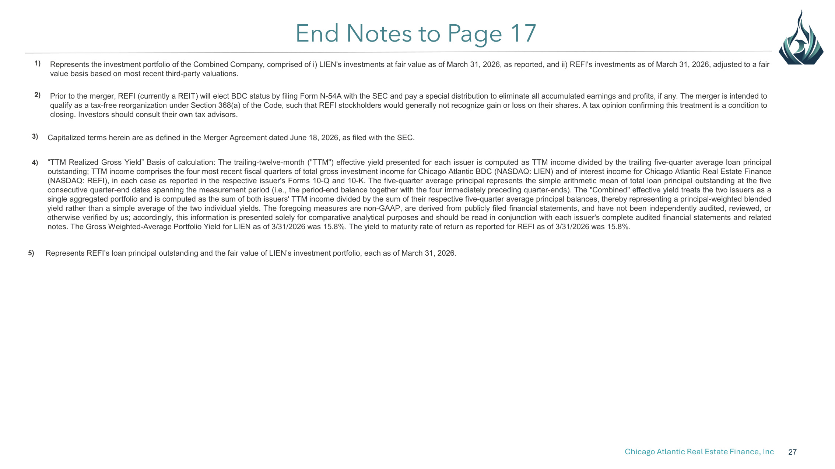
Chicago Atlantic Real Estate Finance, Inc 27 End Notes to Page 17 1) Represents the investment portfolio of the Combined Company, comprised of i) LIEN's investments at fair value as of March 31, 2026, as reported, and ii) REFI's investments as of March 31, 2026, adjusted to a fair value basis based on most recent third-party valuations. 2) Prior to the merger, REFI (currently a REIT) will elect BDC status by filing Form N-54A with the SEC and pay a special distribution to eliminate all accumulated earnings and profits, if any. The merger is intended to qualify as a tax-free reorganization under Section 368(a) of the Code, such that REFI stockholders would generally not recognize gain or loss on their shares. A tax opinion confirming this treatment is a condition to closing. Investors should consult their own tax advisors. 3) Capitalized terms herein are as defined in the Merger Agreement dated June 18, 2026, as filed with the SEC. 4) "TTM Realized Gross Yield" Basis of calculation: The trailing-twelve-month ("TTM") effective yield presented for each issuer is computed as TTM income divided by the trailing five-quarter average loan principal outstanding; TTM income comprises the four most recent fiscal quarters of total gross investment income for Chicago Atlantic BDC (NASDAQ: LIEN) and of interest income for Chicago Atlantic Real Estate Finance (NASDAQ: REFI), in each case as reported in the respective issuer's Forms 10-Q and 10-K. The five-quarter average principal represents the simple arithmetic mean of total loan principal outstanding at the five consecutive quarter-end dates spanning the measurement period (i.e., the period-end balance together with the four immediately preceding quarter-ends). The "Combined" effective yield treats the two issuers as a single aggregated portfolio and is computed as the sum of both issuers' TTM income divided by the sum of their respective five-quarter average principal balances, thereby representing a principal-weighted blended yield rather than a simple average of the two individual yields. The foregoing measures are non-GAAP, are derived from publicly filed financial statements, and have not been independently audited, reviewed, or otherwise verified by us; accordingly, this information is presented solely for comparative analytical purposes and should be read in conjunction with each issuer's complete audited financial statements and related notes. The Gross Weighted-Average Portfolio Yield for LIEN as of 3/31/2026 was 15.8%. The yield to maturity rate of return as reported for REFI as of 3/31/2026 was 15.8%. 5) Represents REFI's loan principal outstanding and the fair value of LIEN's investment portfolio, each as of March 31, 2026.

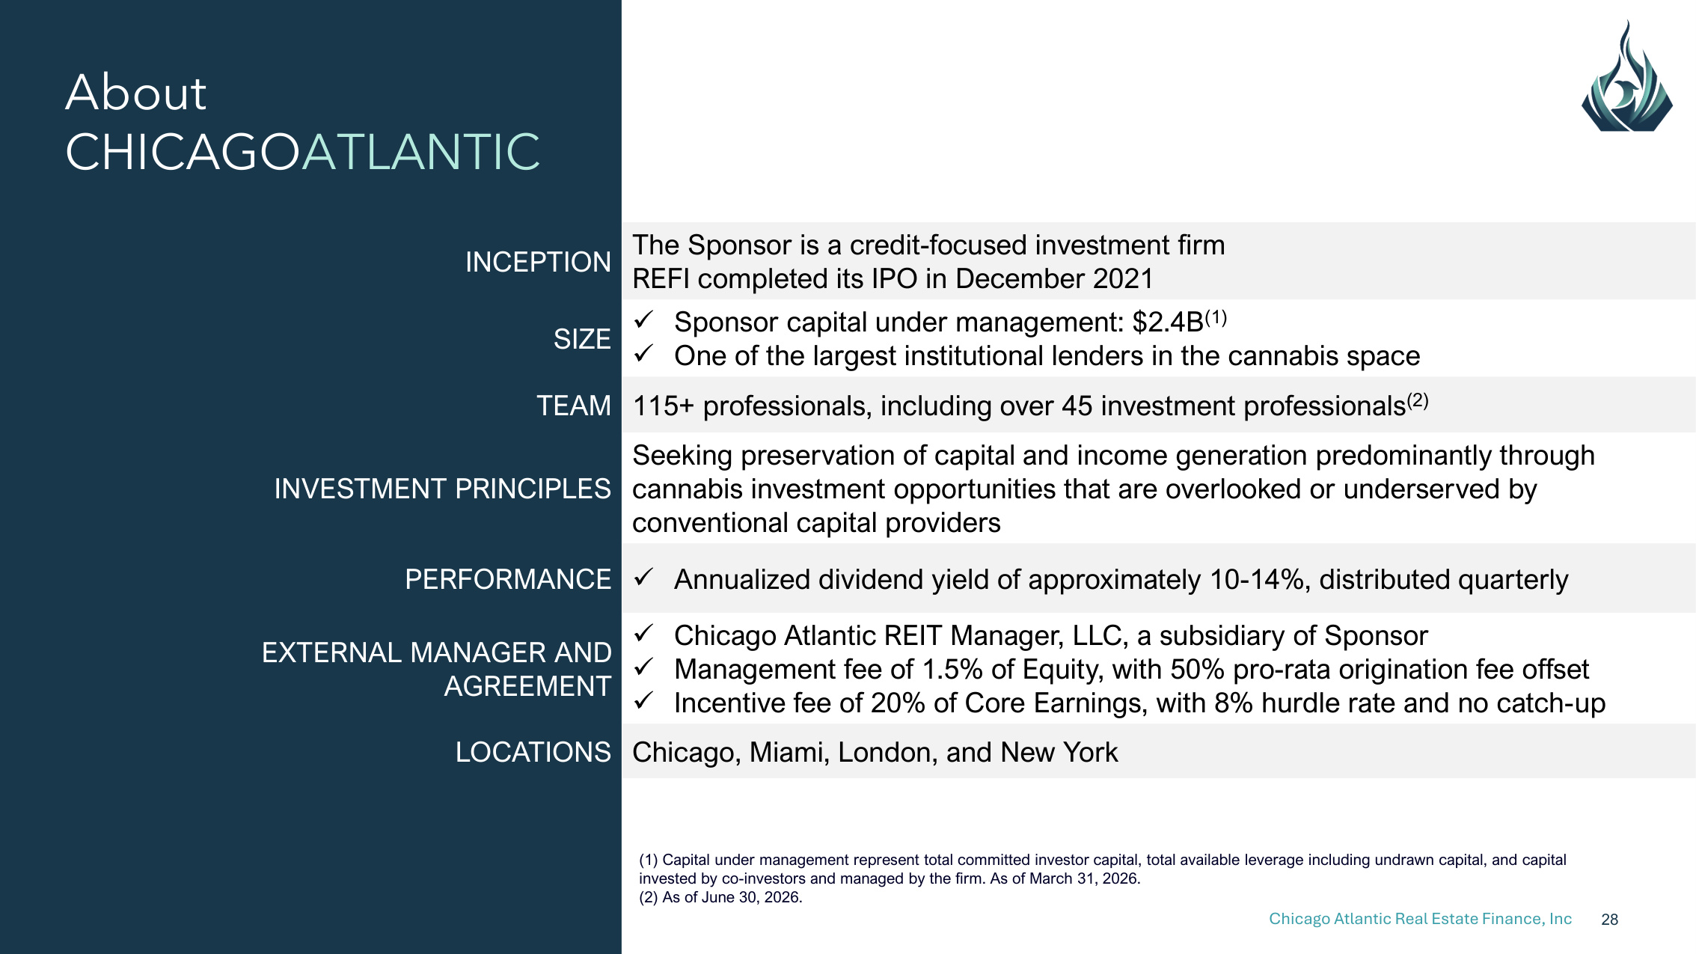
Chicago Atlantic Real Estate Finance, Inc 28 About CHICAGOATLANTIC (1) Capital under management represent total committed investor capital, total available leverage including undrawn capital, and capital invested by co-investors and managed by the firm. As of March 31, 2026. (2) As of June 30, 2026. INCEPTION The Sponsor is a credit-focused investment firm REFI completed its IPO in December 2021 SIZE Sponsor capital under management: $2.4B(1) One of the largest institutional lenders in the cannabis space TEAM 115+ professionals, including over 45 investment professionals(2) INVESTMENT PRINCIPLES Seeking preservation of capital and income generation predominantly through cannabis investment opportunities that are overlooked or underserved by conventional capital providers PERFORMANCE Annualized dividend yield of approximately 10-14%, distributed quarterly EXTERNAL MANAGER AND AGREEMENT Chicago Atlantic REIT Manager, LLC, a subsidiary of Sponsor Management fee of 1.5% of Equity, with 50% pro-rata origination fee offset Incentive fee of 20% of Core Earnings, with 8% hurdle rate and no catch-up LOCATIONS Chicago, Miami, London, and New York

